Word embeddings

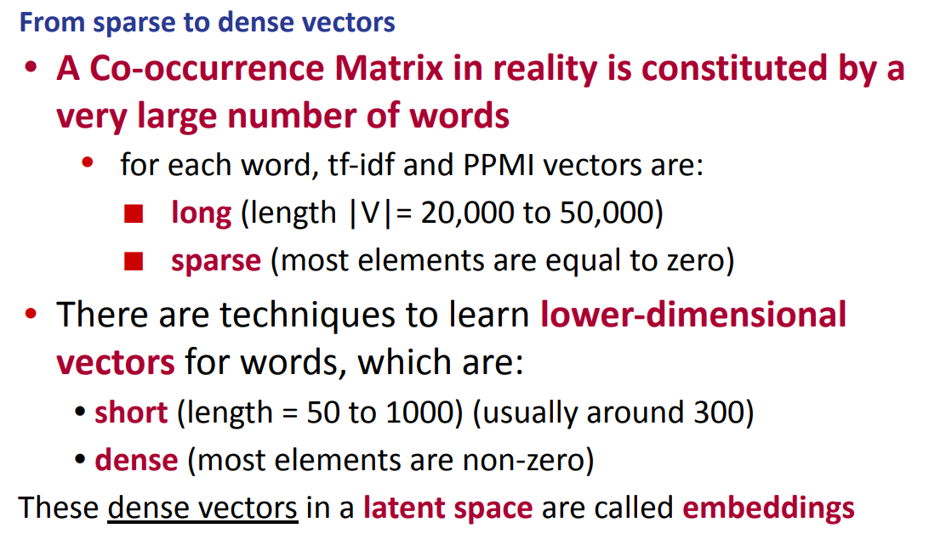

How to construct word embedding in a different way

The matrix was very sparse, 20.000-50.000 words, not so easy to store this quantity of words, also very sparse, most elements are 0. It is a waste of memory

We try to use a new technique that has a lower dimensional vector, start from something sparse and we shrink to something lower (usually 300). And we create dense matrix, most elements are not zero.

These dense vectors are called embeddings and they live in the latent space

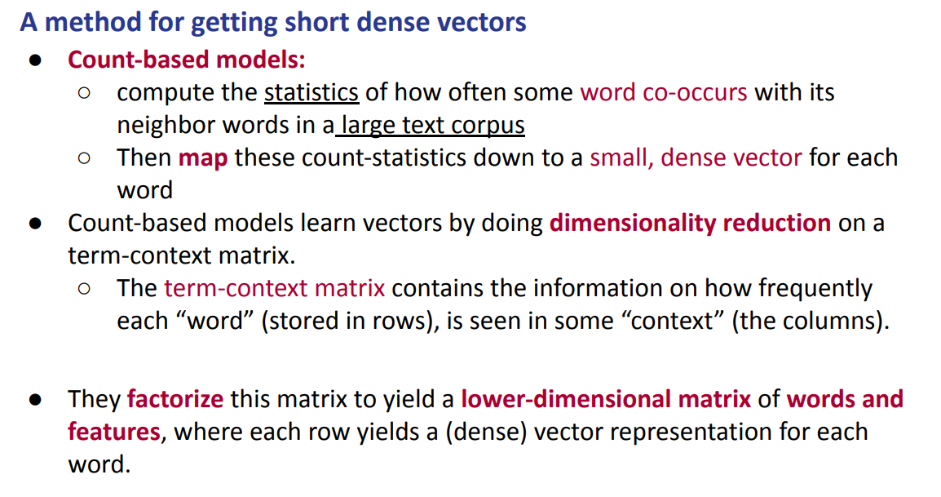
Use some algebra properties. We start to compute the statistics of how often some word co-occurs together. We want to map these big matrices to a small dense vector (that is our goal). We do dimensionality reduction. The matrix we create is called a term-context matrix and the rows are the words and the columns are the context. A word is not anymore related to each single context word in the column but rather to something that is more abstract (a sort of dense embedding).

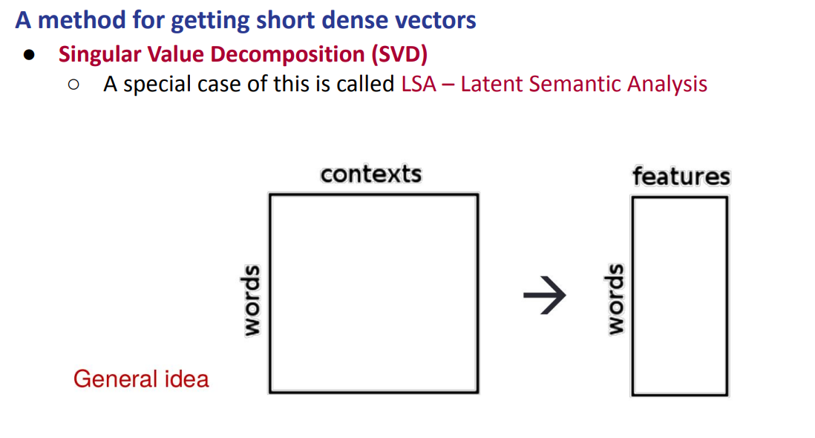
SINGLE VALUE DECOMPOSITION (SVP)
Is the most common technique. The general idea is that we start with the big matrix and to obtain a matrix where the rows (words) remain the same but the columns are not contexts anymore but features (that are much smaller in dimensionality).

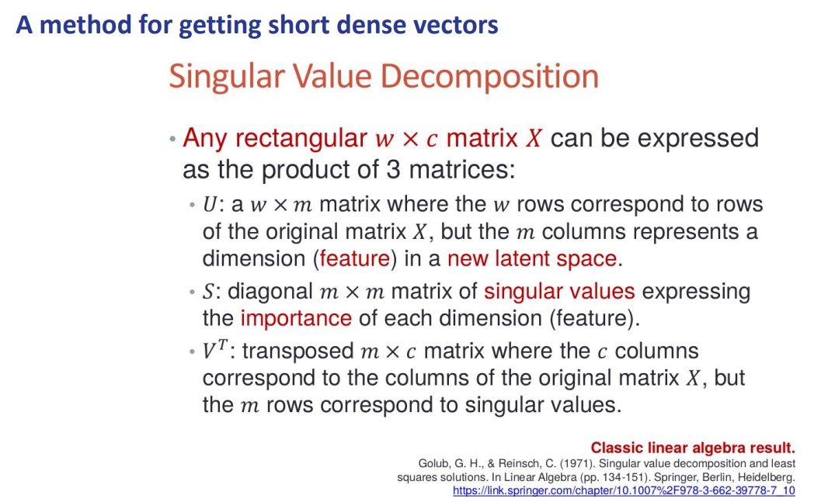

Given any rectangular matrix $w × c$ (words x context) that matrix can be expressed as a product of three different matrices
- U: $w × m$. Where w are the words and m are the columns that represent the new latent space (the new feature that we want to archive)
- S: is called singular values matrix $m × m$ it is diagonal and expresses the importance of each dimension (feature).
- V^{T}: is the transposed of the original matrix $m × c$

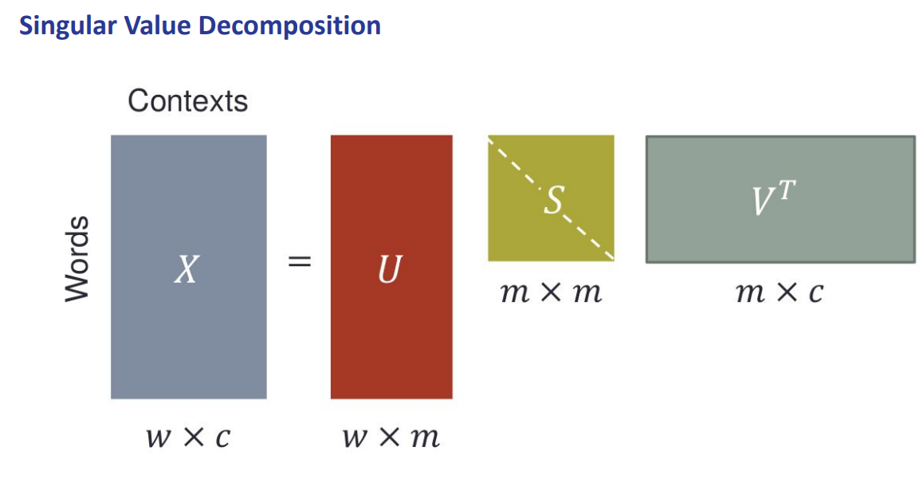

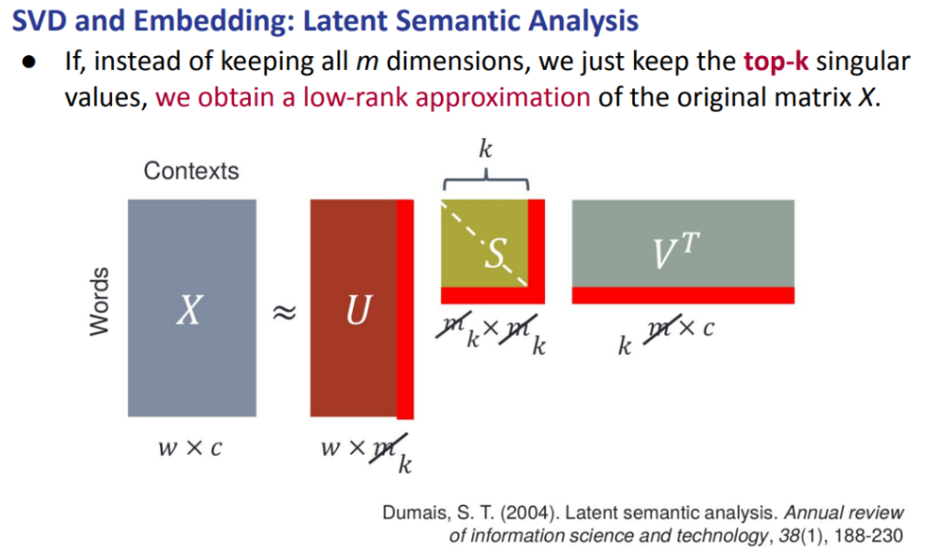

Instead of being interested in the m dimensional matrix we want something like k that is smaller than m.

And it tells us that these k features are actually the important ones. If we take the first k values they will be the most important one given our original matrix.

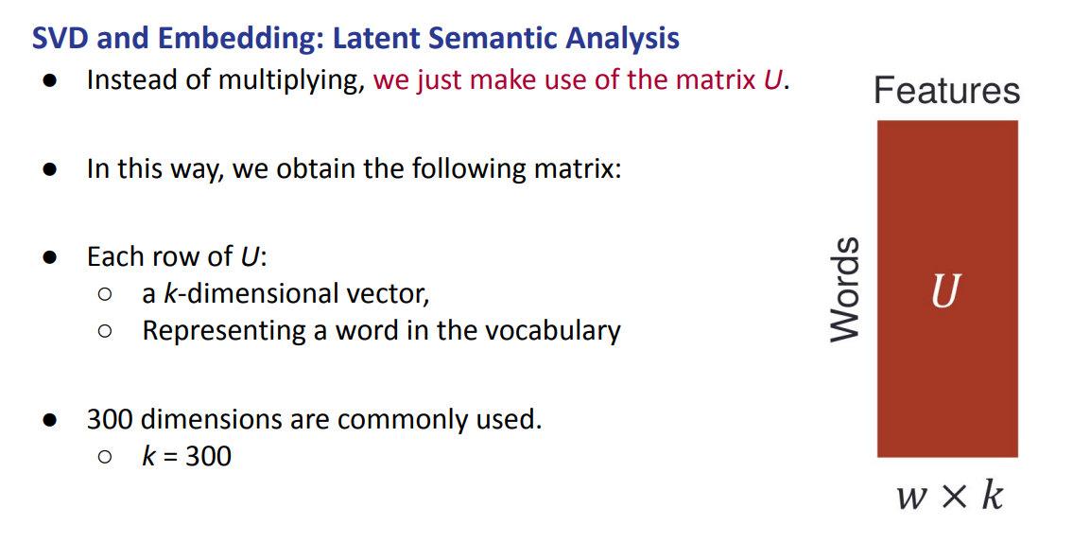

Each row corresponds to a word, we will not lose any word. But we shrink to something smaller

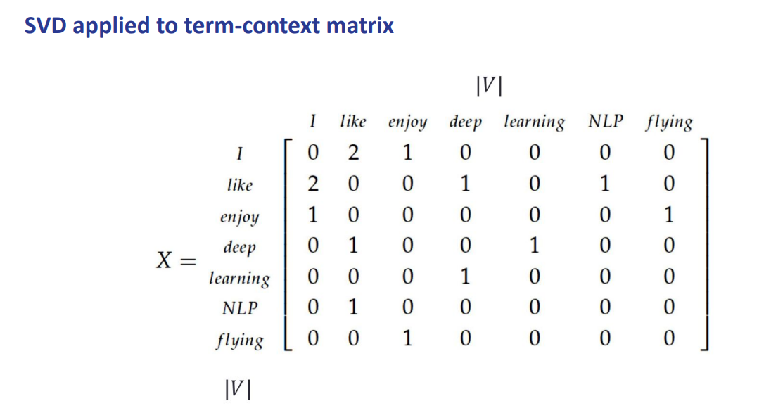
As an example you build the matrix, at the beginning it is big as the number of words

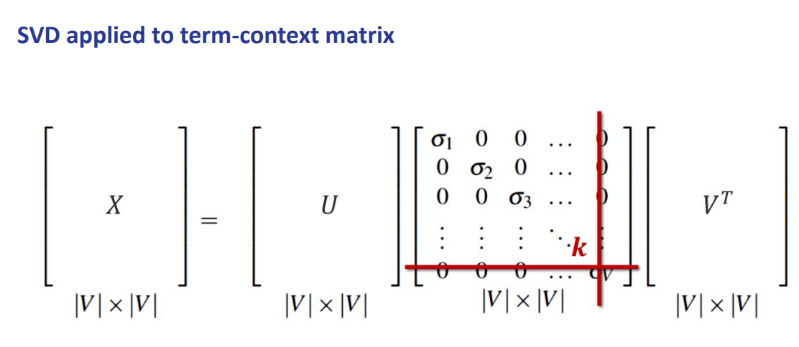
then you exploit the algebraic property and you rewrite the matrix with three other matrixes and we take the first k value that we are interested in

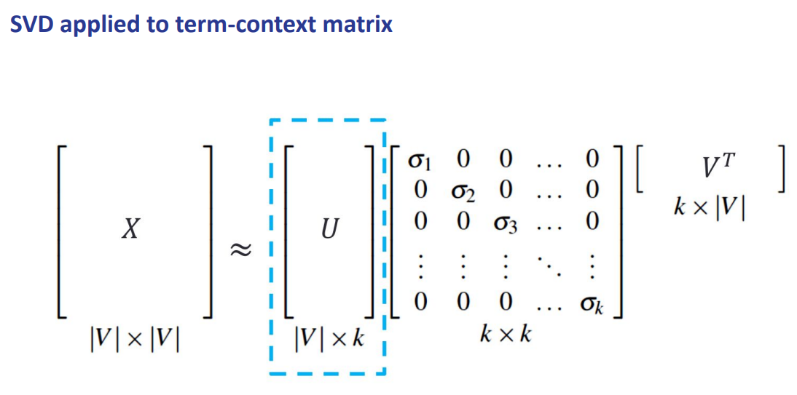

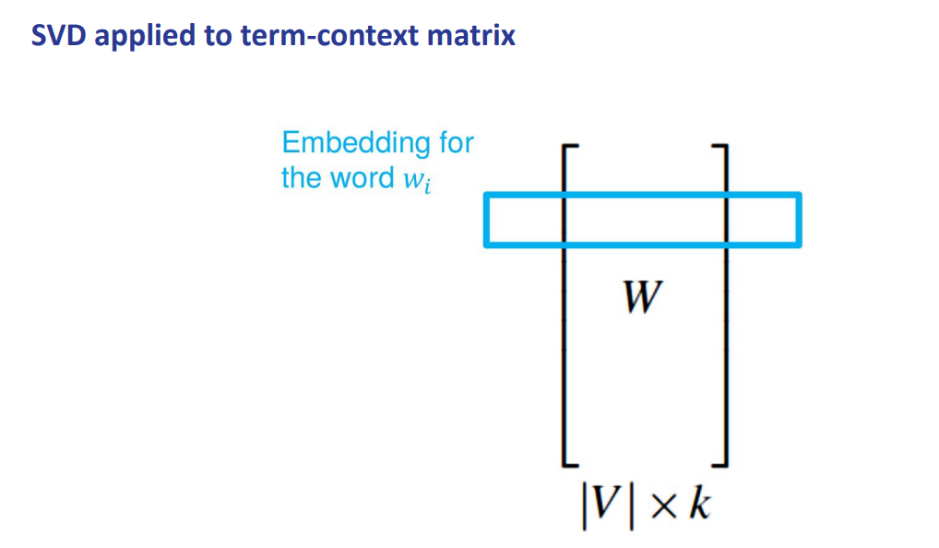
Each row corresponds to an embedding of the word.

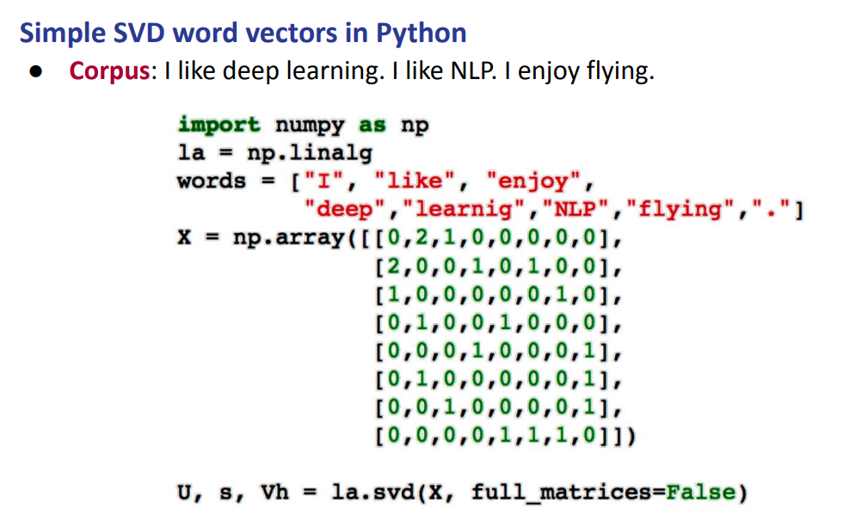
In numpy it is already implemented. You can give as input your matrix and it gets as output the decomposition in three matrices that we are interested in. Then you k to whatever value you want, you can cut in the threshold that you want.

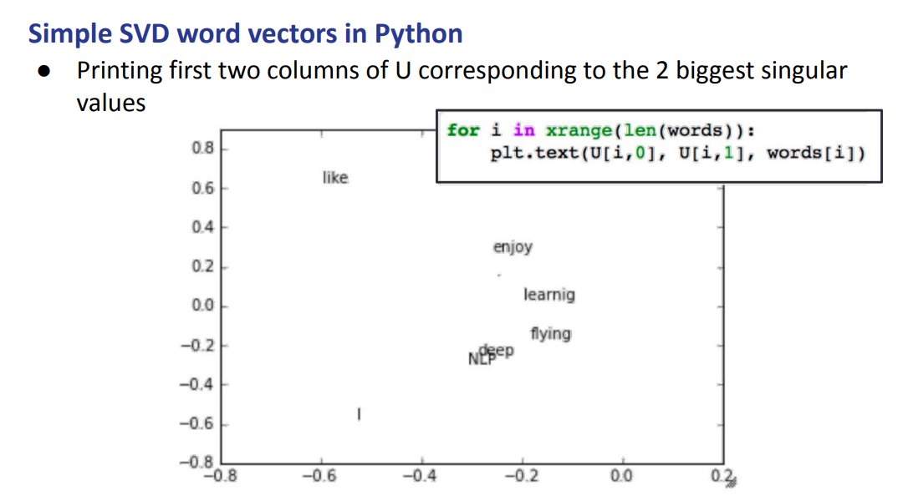

We can plot the first two values. We can see that NLP and deep occurs together and so the two words are closer to each other

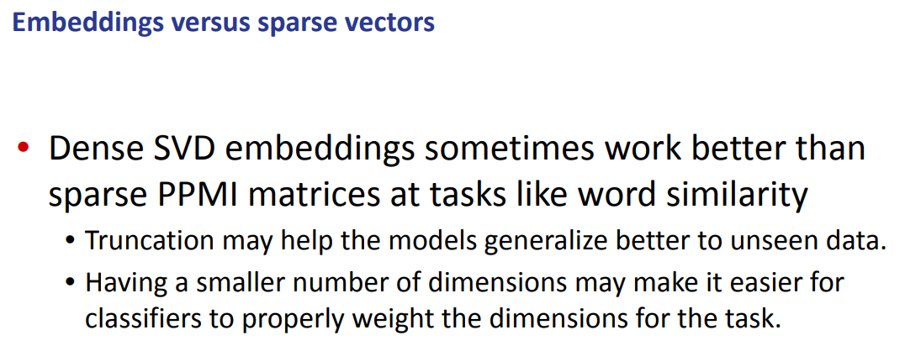
Is a general method that works using the algebraic property. You still need to build the first matrix, so you need to save it and store it somehow. Then you can build the smaller one and use it for the application you want

There is the initial step where you need to save and compute the big context-word matrix.

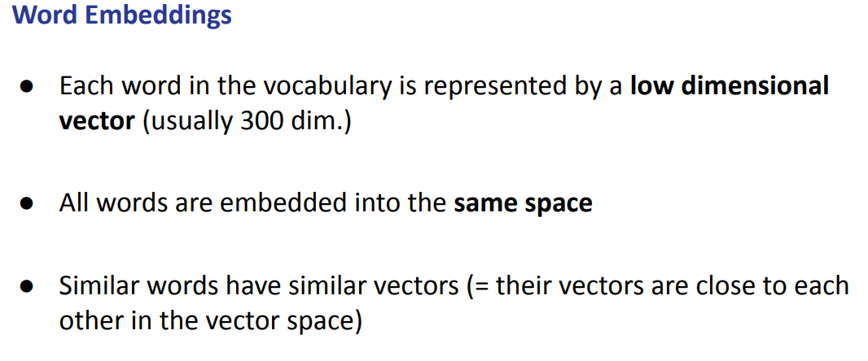
Word embedding: low dimensionality vectors that goes from 300 to 1000 dimension. They are not big as context matrix.

Also all words are embedded into the same space

they all are in the same space and so we can do some matrix between them. Similar words have similar vectors and so the cosine distance should be close, they should preserve all the properties

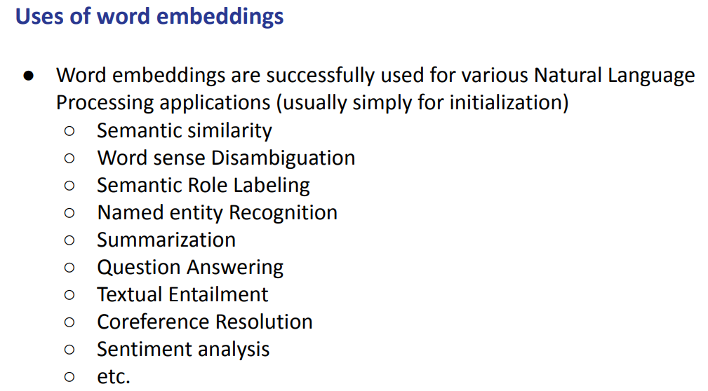
Word embeddings are used for various NLP tasks, when you want to build a classier you need some sort of initialization.

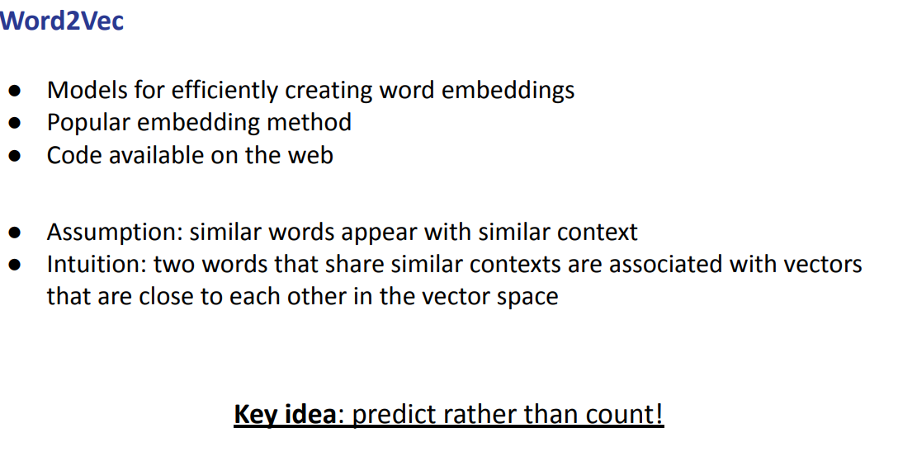

Goal: we try to avoid the sparse matrix before, we start straight with the dense matrix.
One of the first ways was WORD2VEC. It builds word embedding without directly building the sparse matrix.

Assumption: similar words appear in similar context, idea that two words that are similar are associated to similar vectors close in the vector space.

The idea is that instead of counting we want to predict, we frame the task in a different way

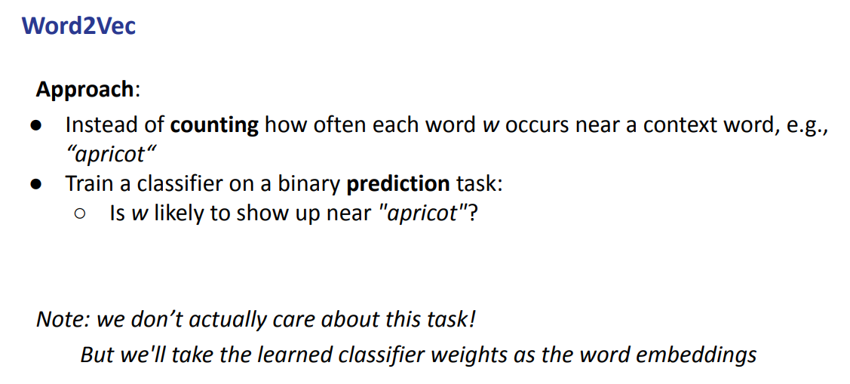
We redesign the task to build the dense vector. We want to build a classifier on a binary prediction task.

We actually do not really care about the task. We want to build a classifier but then we will take the classifier weights as word embedding

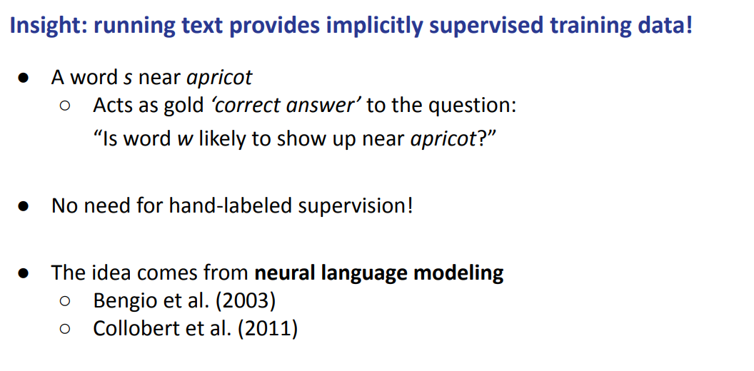
To build the classier you usually need annotated data, but in our case there is no need to annotate any data because the sentence itself will be the supervisor of our training data. The sentence itself contains words. We just take the text at it is and we check if two words are closer

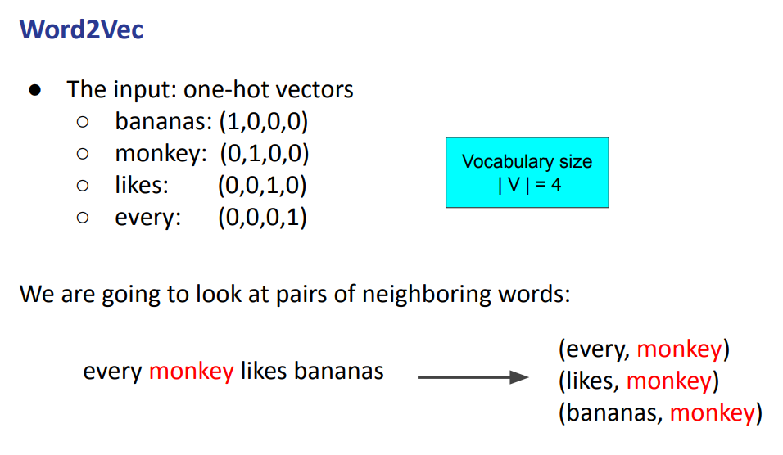
We build a pair of words, the will be our training set.

For building negative samples we can just take random words like fashion and it will provide the negative instance.

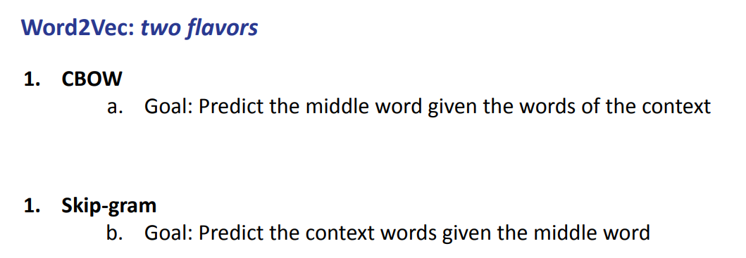

Word2Vec we have two different techniques, they both follow the general idea, but they change in what to predict

- CBOW: it tries to predict the target word given the context word. Predicts monkey given every … likes bananas
- SKIP-GRAM: takes as input monkey and tries to predict every … likes bananas.

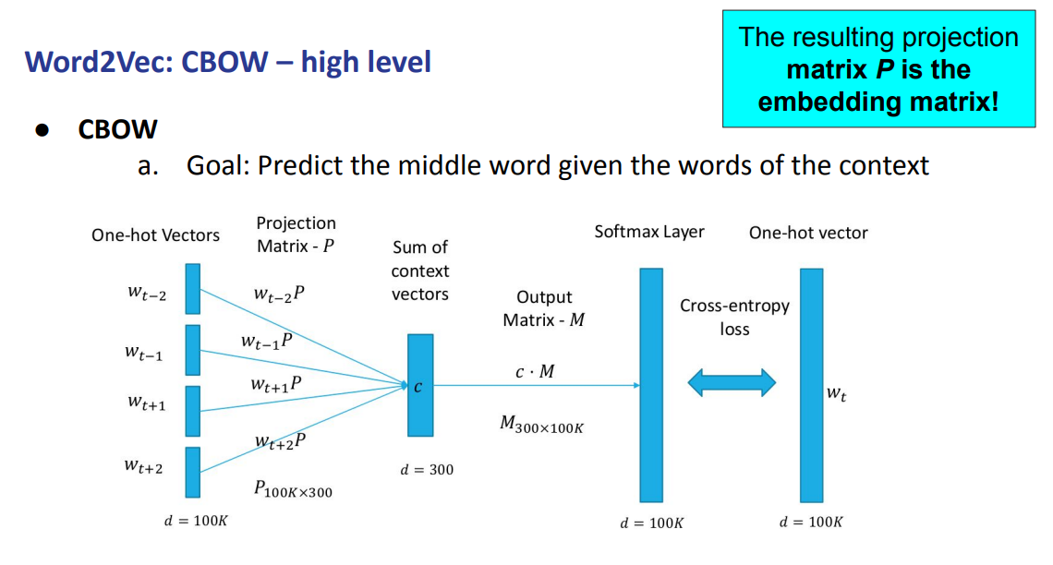
We have our context (w_{t-2}, w_{t-1}, w_{t+1}, w_{t+2}) and we try to predict w_{t} (monkey).

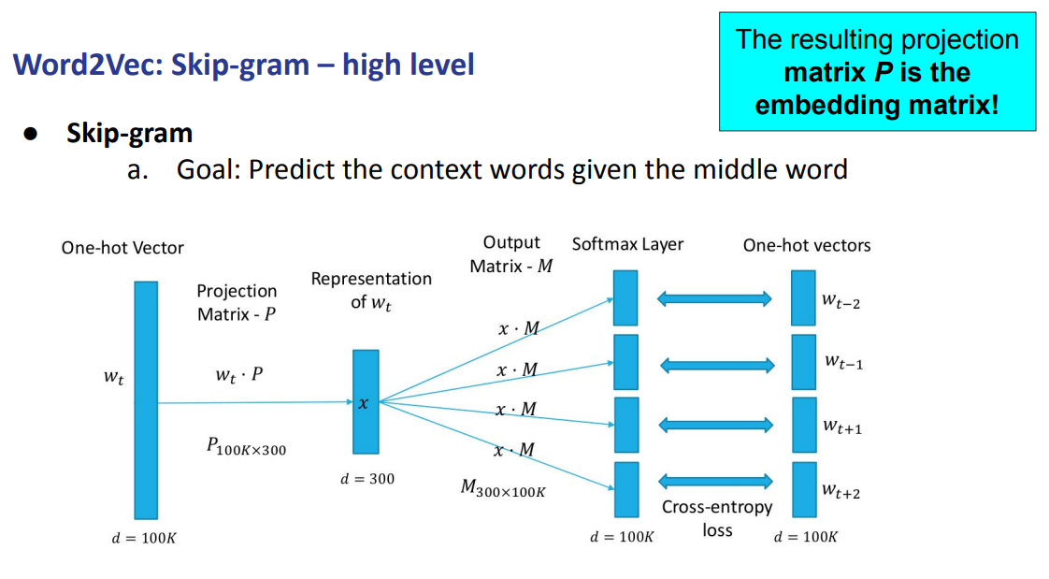
Is similar to CBWO, exactly the other way around.

It takes as input a single word (the target) and predicts the context.

As before, the resulting projection matrix P is the embedding matrix. Once we trained this classifier in this way each word will be associated with one dense vector. The dense vectors are used to train the classifier.

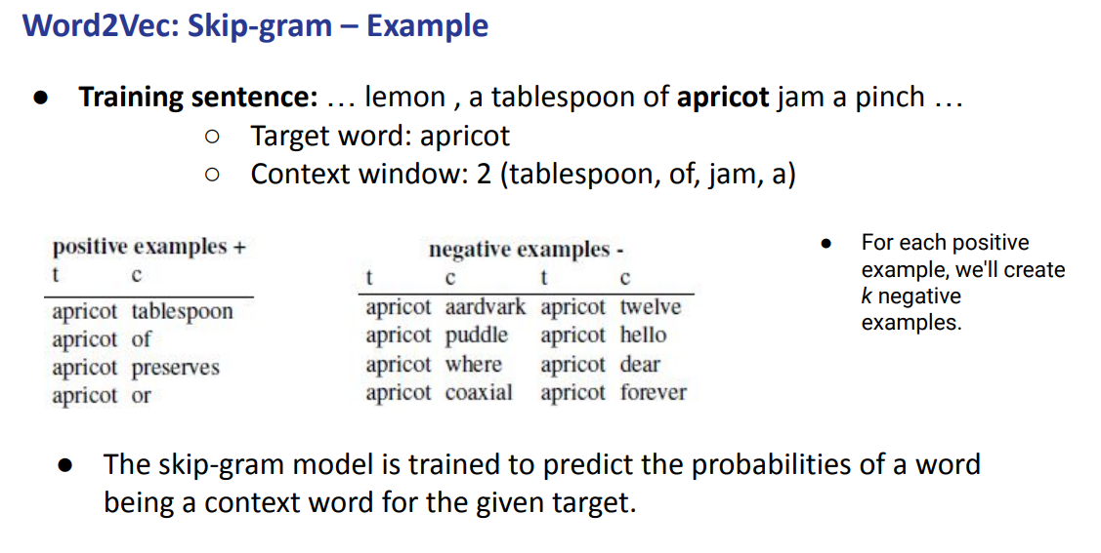
How to build positive instances and negative instances. We have our sentence with target word apricot and a context window of dimension 2 (2 words on the left, 2 on the right)

For each positive example we can build k negative examples (usually we provide more negative examples and we simply take a random word)

The we can train our model

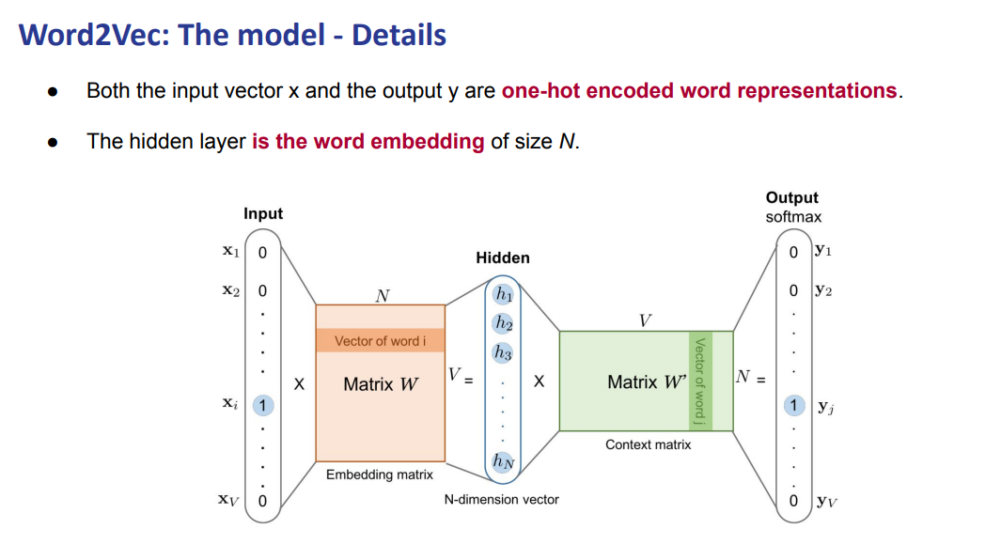

At the end both the input and output are one-hot vector and the hidden layer are the word embedding. We will use the hidden layer of the neural network as word embedding.

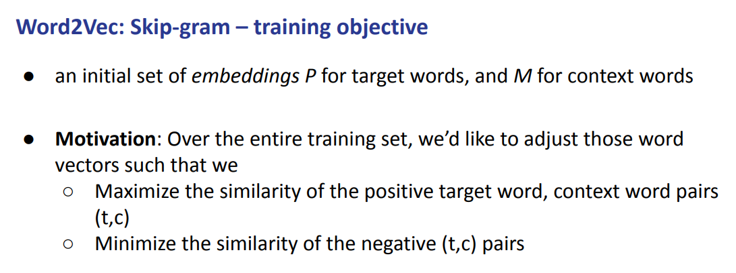
At the beginning you need some sort of initial weight. When you train your model you start with random values and then during the training they will be adapted to the task of interest.

We want to maximize the similarity of the positive target word with a context and we want to minimize the similarity of the negative words.

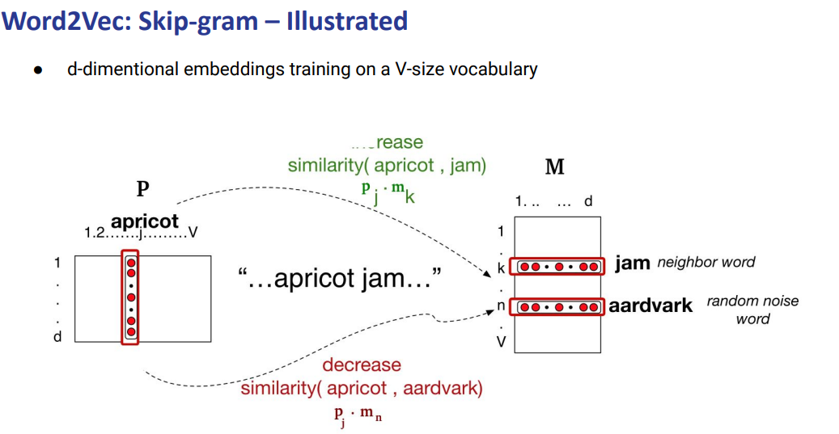
apricot (target)
jam (context)
aardvark (random noise word)

We want to increase the similarity between apricot and jam and decrease the similarity between apricot and aardvark.

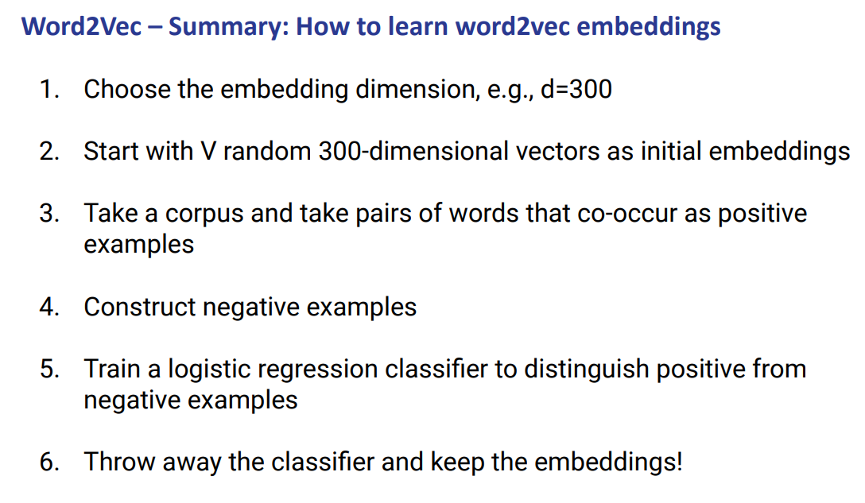

6 steps in order to learn word2vec embedding
- You need to choose at first your embedding dimensionality
- You start with a random initialization of the network
- You take a corpus and a paris of words as positive
- You construct the negative
- Train the classifier to distinguish the positive from the negative example
- Throw away the classier and keep the embeddings

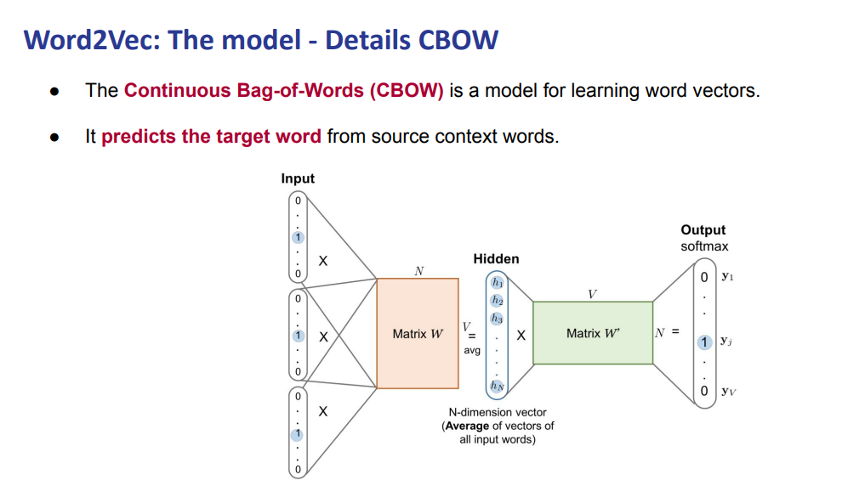
At the end both sum or average are fine
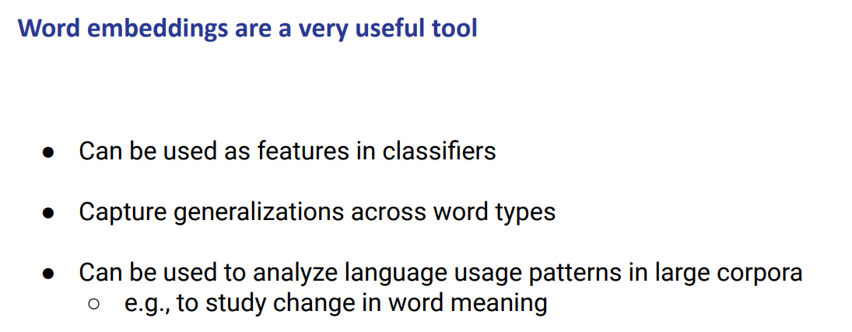
Word embeddings are a useful tool, they actually capture generalization across word types, can also be used to analyze language usage patterns in large corpora (like studying the change of meaning of a word)

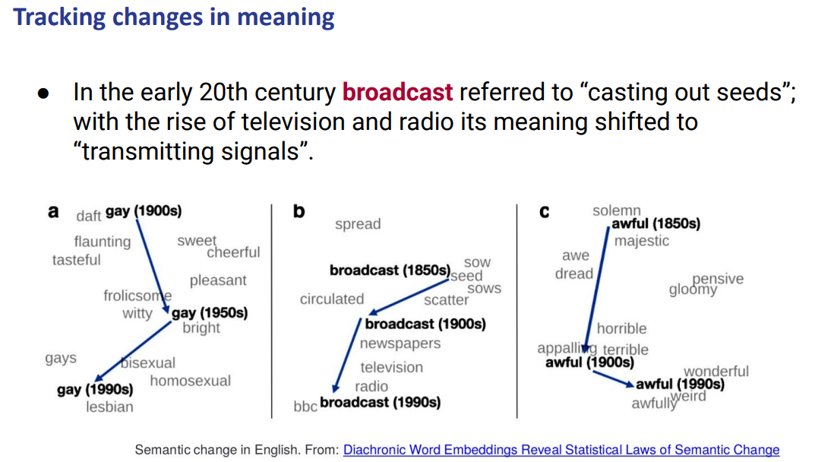
we can do some analysis on some text data

Embedding learning algorithms
With Word2Vec you can compute word embedding. It has two variants CBOW and SkipGram. Given an input sentence it can build our positive training sample and negative training sample and then build the classifier

They are two details that are missing

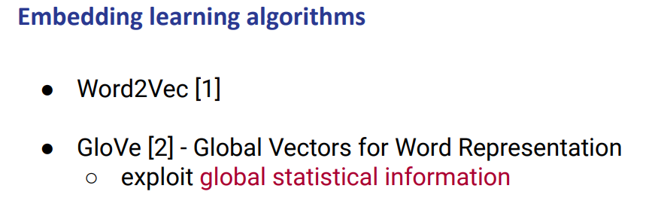

We are missing some global statistics about the corpus. When we build the positive train example we just look at each sentence in isolation. But actually we do have the full corpus at the beginning and so we could build some global statistics about the words and we can incorporate this about the training

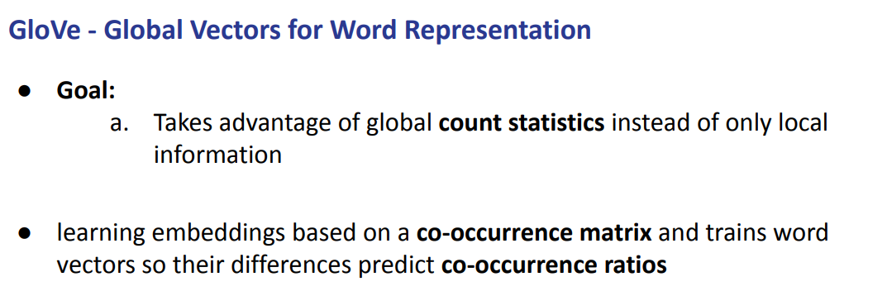

The goal of GloVe is to takes advantage of global statistics instead of only local information

We want to capture the global corpus statistics
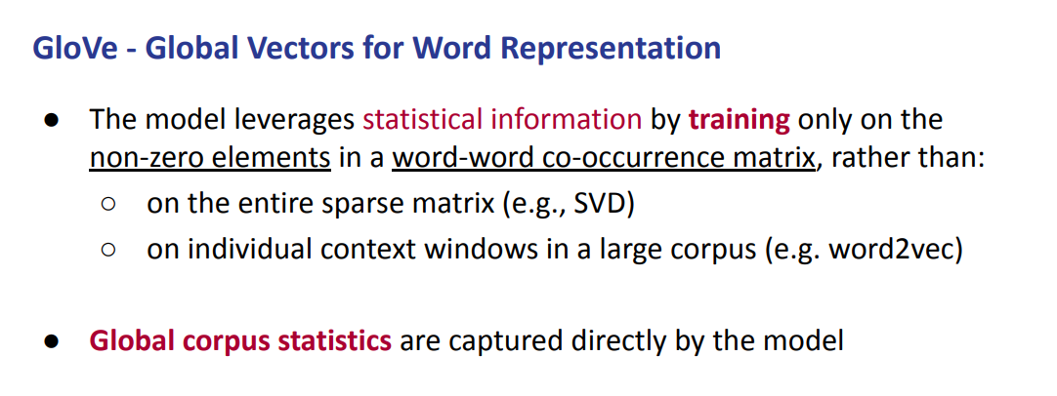

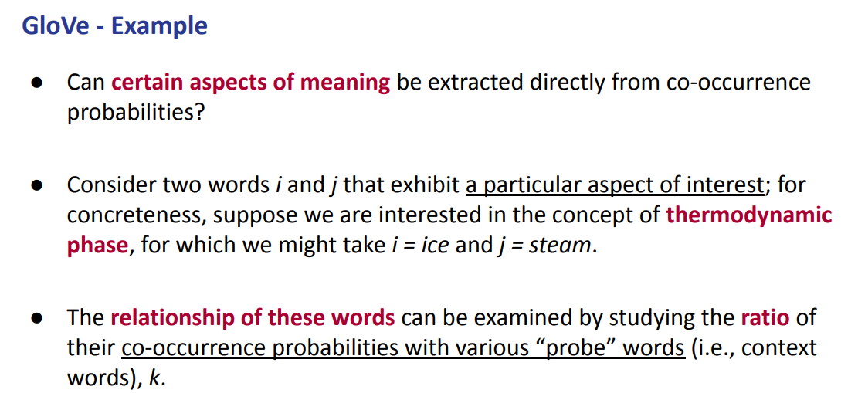

If we consider two words they might actually exhibit a particular aspect when they are inside the co-occurrence probability

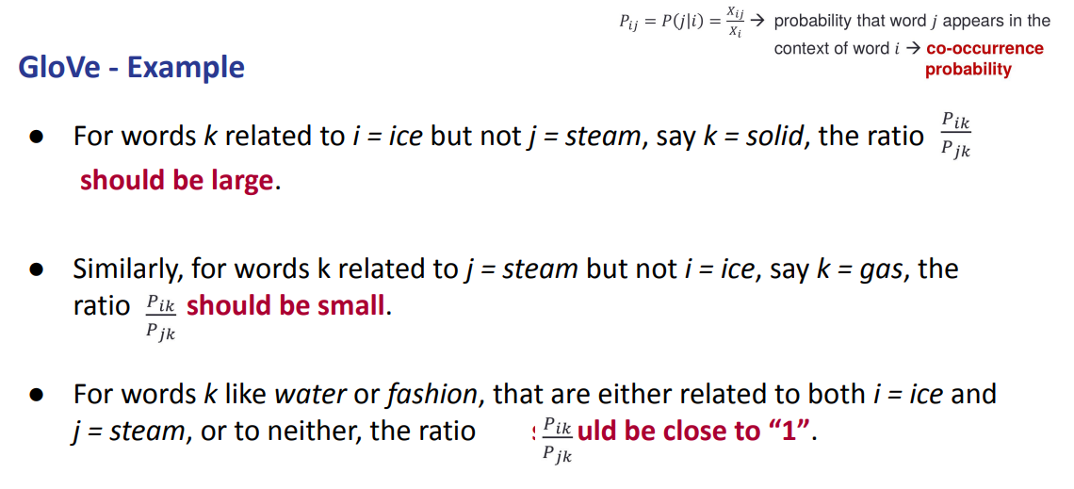
for a work K related to ice but not to steam (ex: solid) the ratio of the probability should be large

if we take a word like gas that is related to steam but not to ice then the ration should be small

for words that are either related to both ice and steam (like water) or words not related at all (like fashion) the ratio of this probability should be close to 1

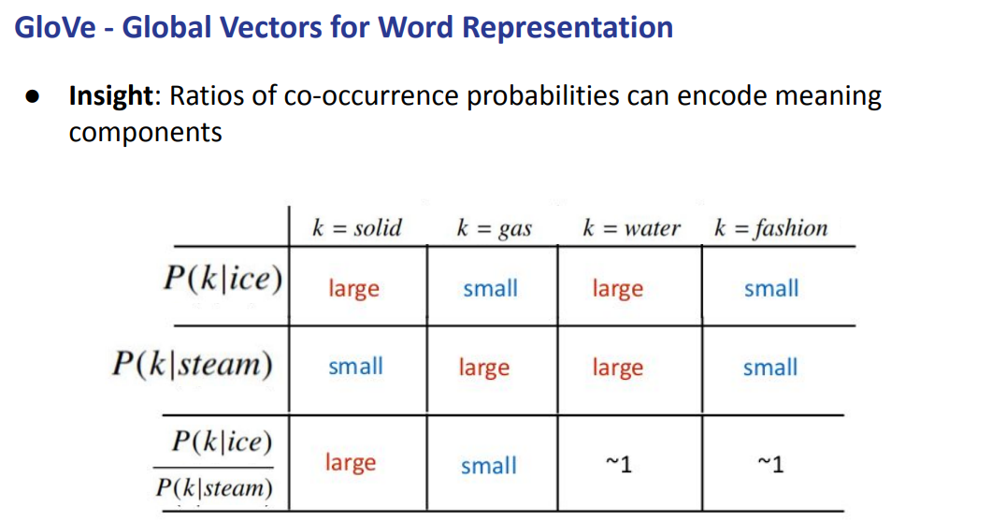

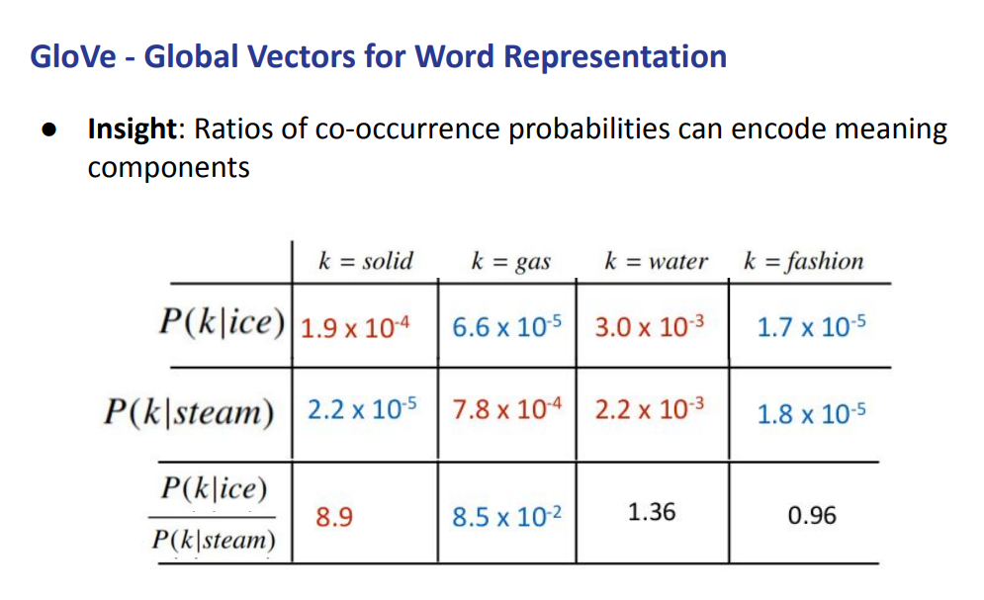

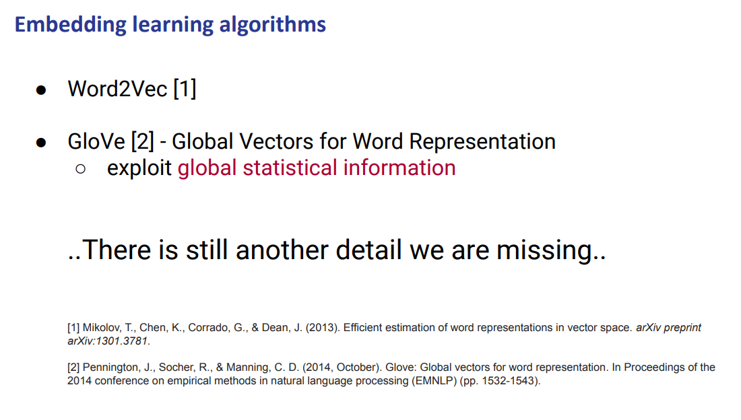

Now we have one method that exploits local context, one that exploits global context. Both methods fail (in one way or another) in taking in account that there could be in the corpus other words that did not appear at all in the previous one, and so we would not have word embedding.

We have to invent a new model that somehow try to generate word embedding even if that word didn’t appear before.

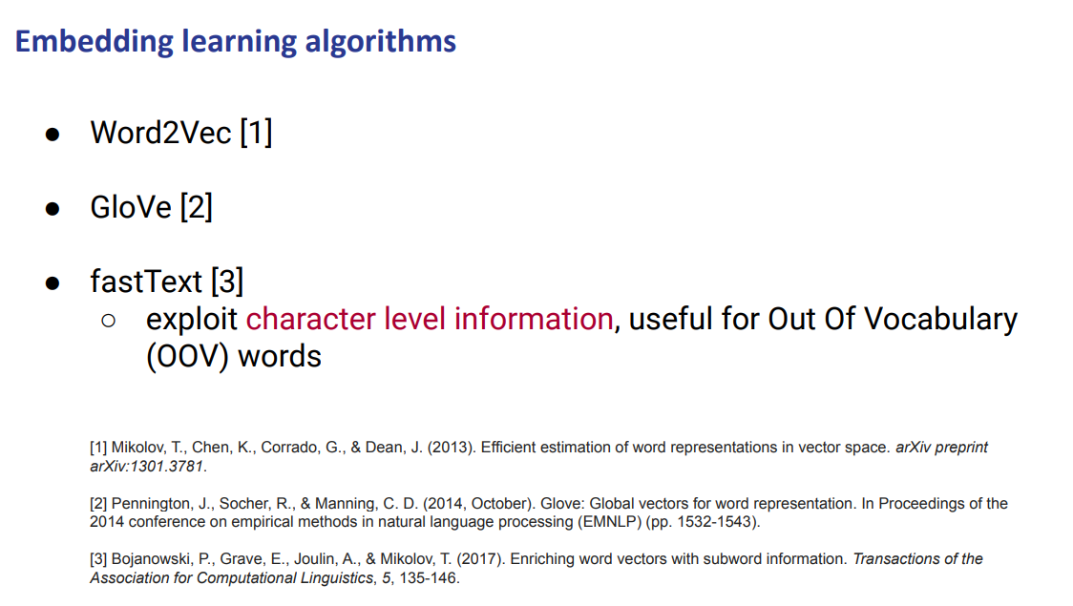
there could be some words that did not appear at all, so those words will not have any word value, maybe we can train a model that somehow try to generate word embedding even if a word did not appear at all before.

this is the Out Of Vocabulary (OOV) another method is fastText

Take Word2Vec and we can take those method and on top of those method we want to add some other information that comes from single letters in our corpus
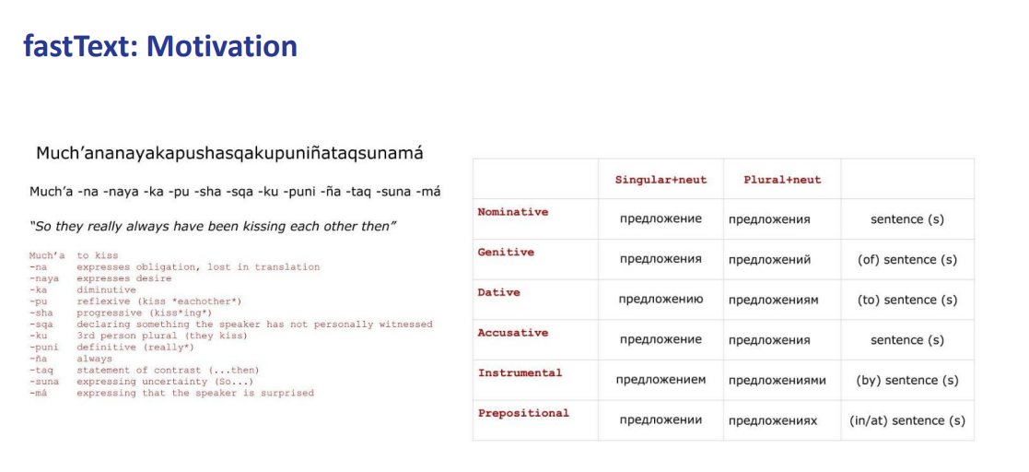

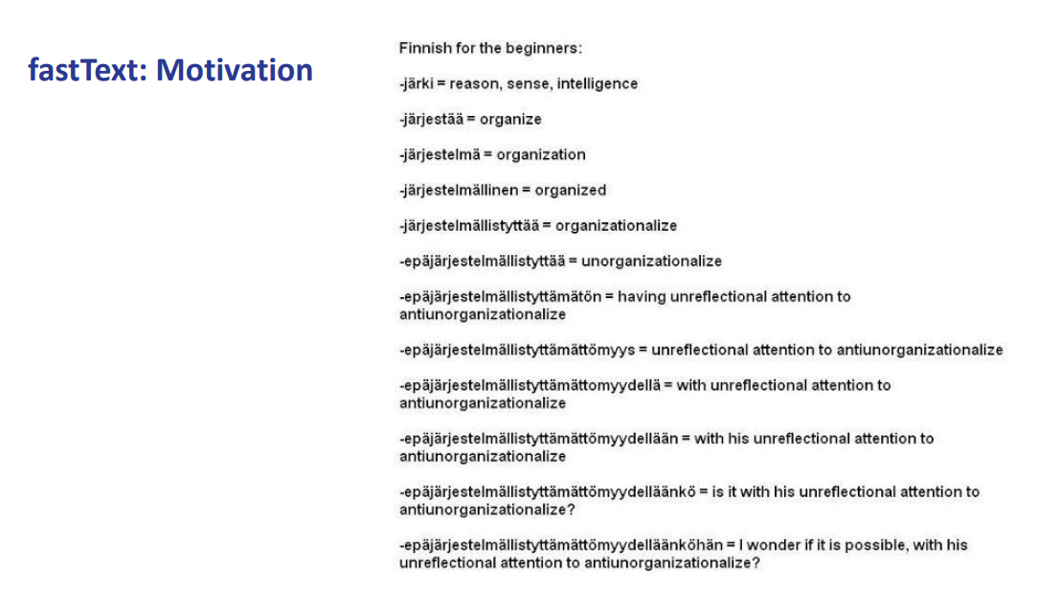

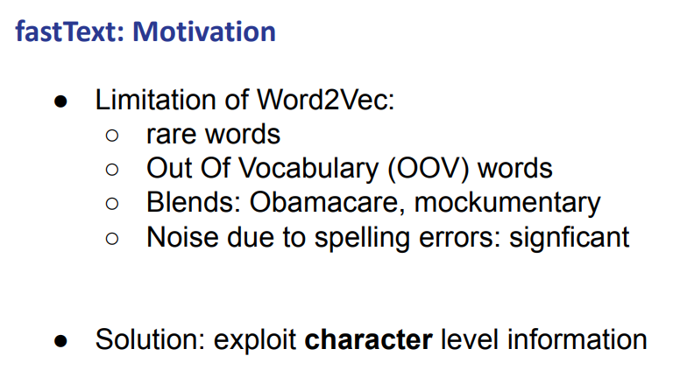

maybe just for a single letter you miss the entire word.

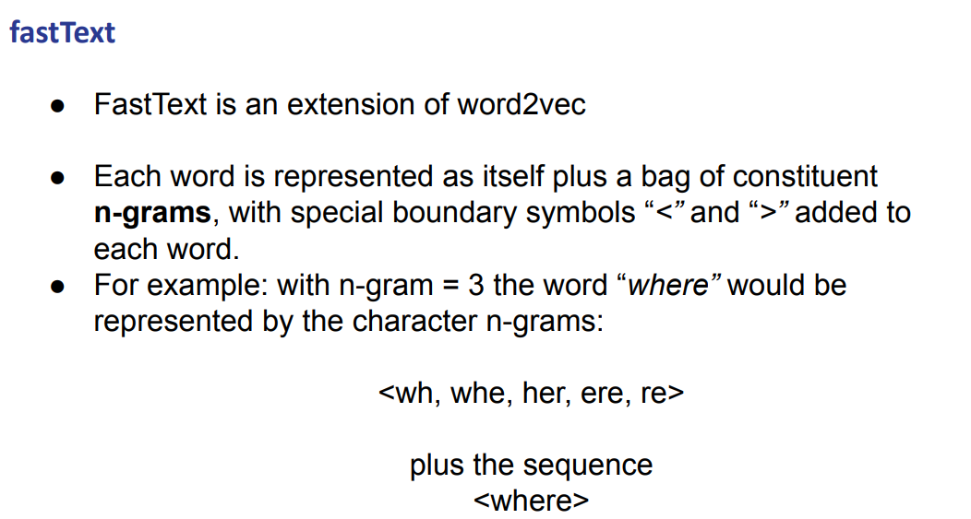

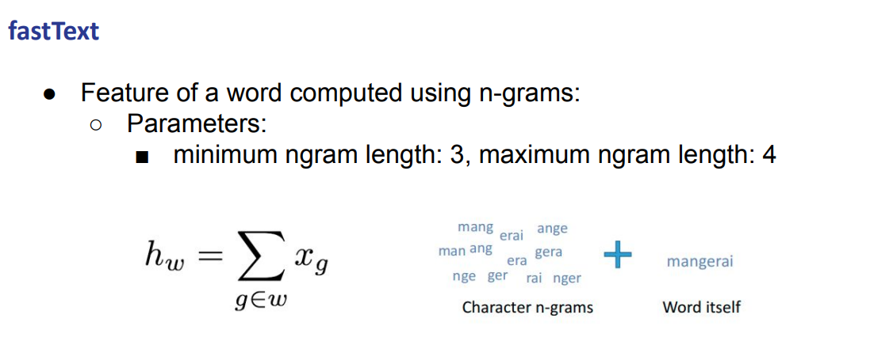
If we miss the word, maybe we will not miss all these n-gram, and so we can actually construct at least something.

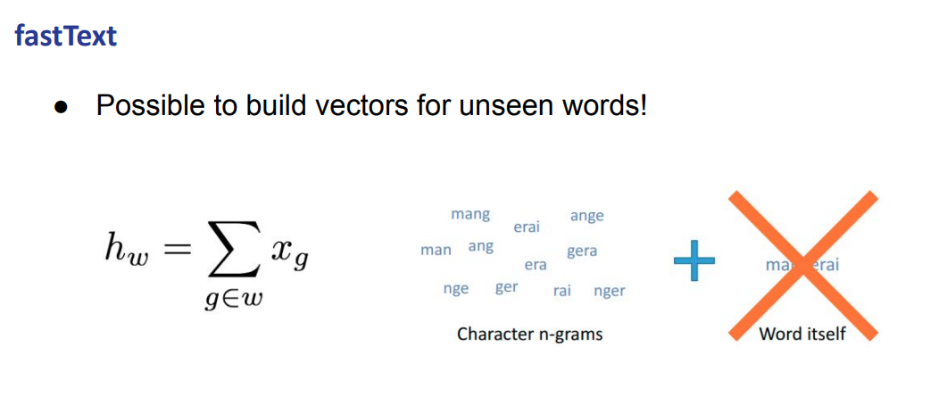

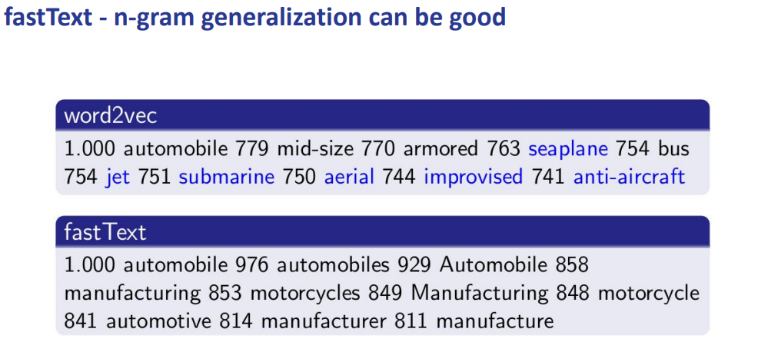
(the 0. is missing)

We give more weights to something that share more text

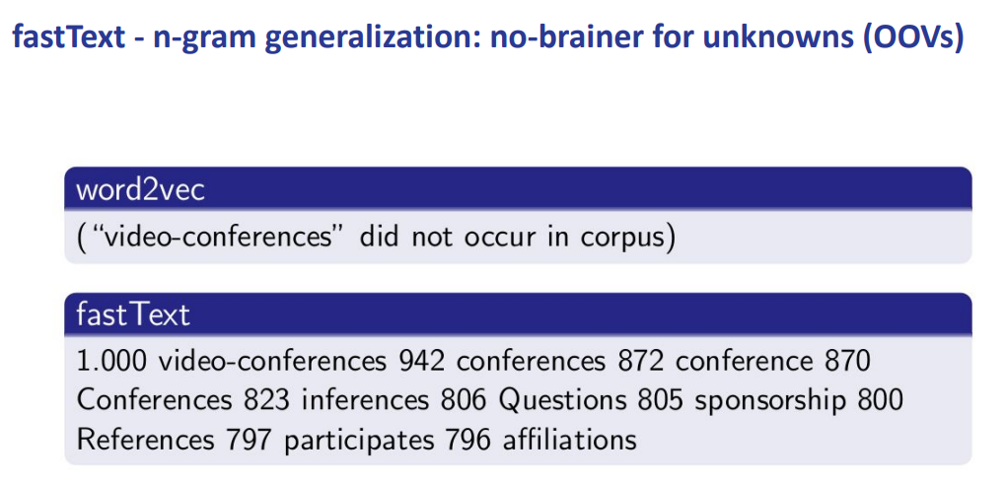

if we do have as input a word that never appeared in the vocabulary

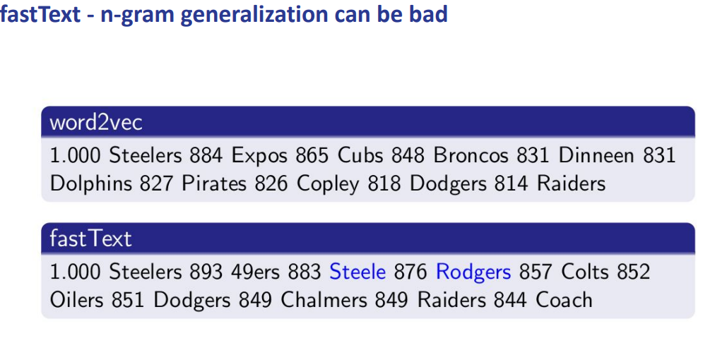

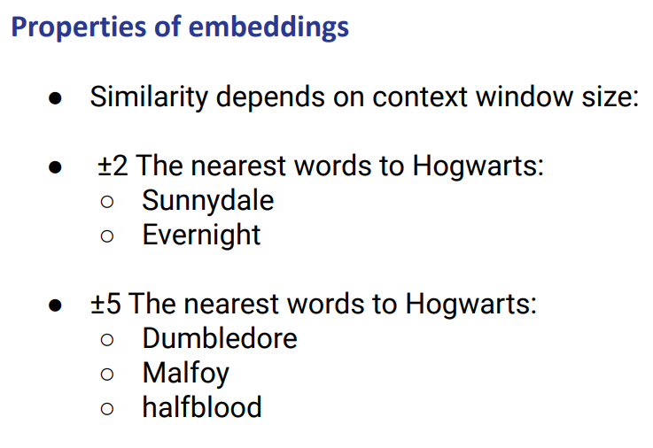

We see 3 types of embeddings. Each of them try to address some particular aspect

there are different parameters, the size of the context window will impact on the quality of embedding (a small context window should get something more syntactic, a longer context window will get something more semantic)

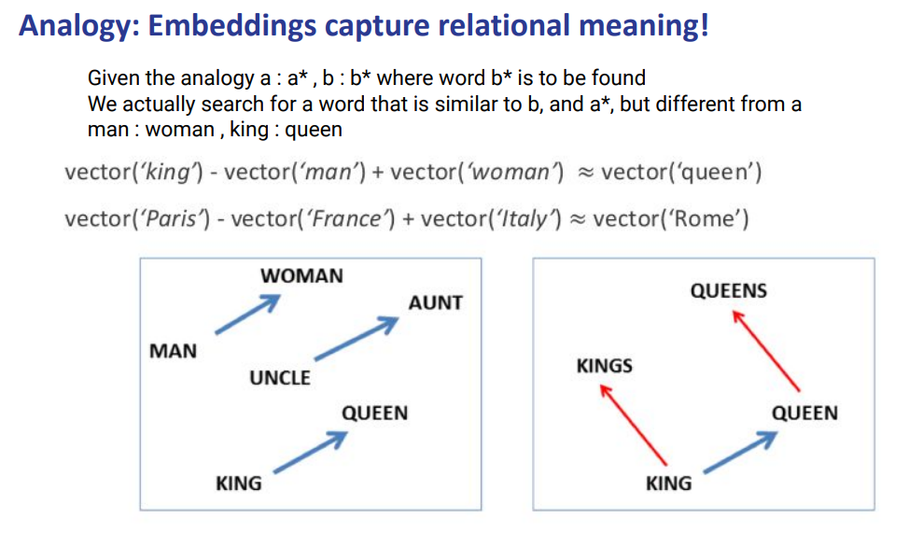
With embedding we can build some analogy patterns. We can “play” with the distance.
If we say

man:woman = king:queen

we can play with the distance and there should be a similar vector man woman with x and king

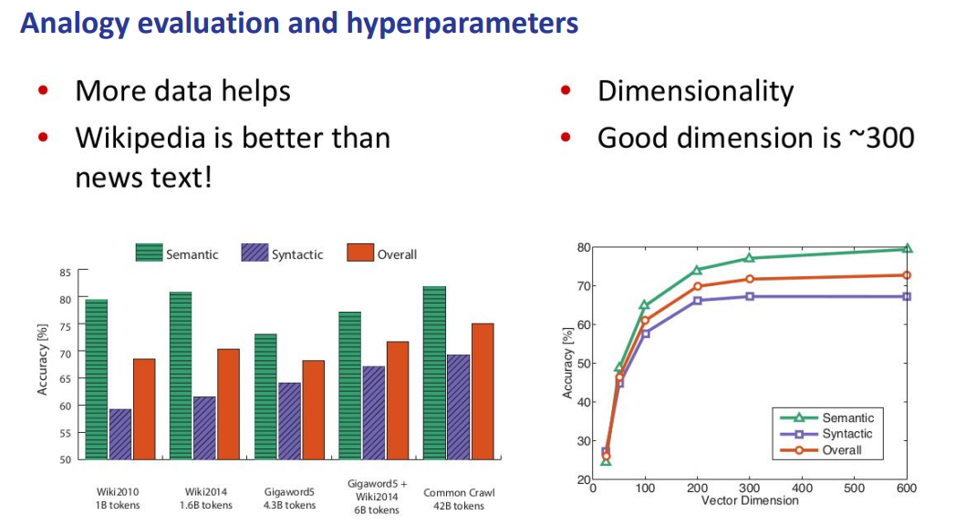
There is a lot of embedding. usually more data helps, but better date is better than a lot of data

Wikipedia has quite a big dataset and is well written. Rather than something on the web that might be less well written.

Usually training on something that is still big (wikipedia contains 1 billion tokens and it is clean) it will get better results than something trained on a bigger corpus but more noisy. There is always a sort of tradeoff.

Of course it depends on the task, bigger corpus might be better in some cases

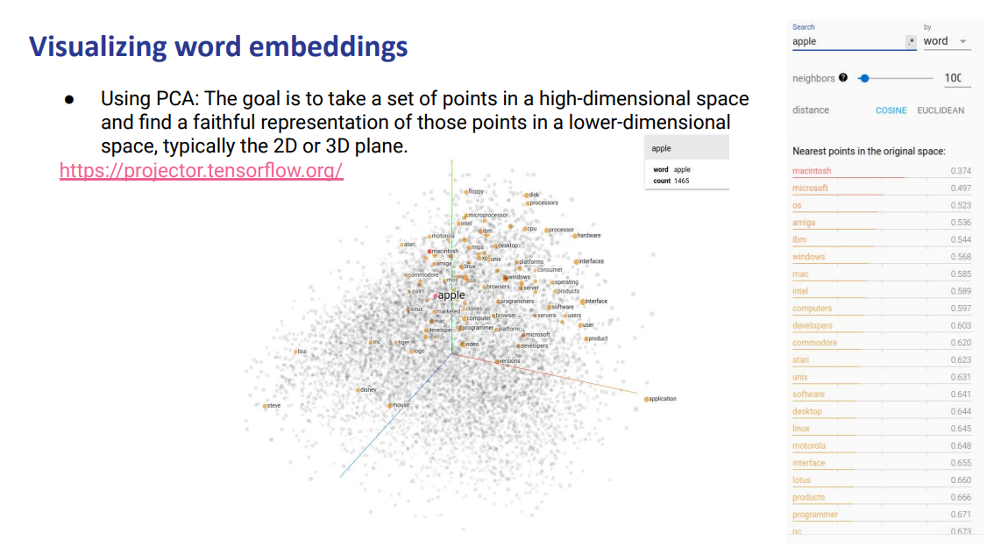
You can visualize word embedding. PCA (principal component analysis) plot the vectors in 2D or 3D

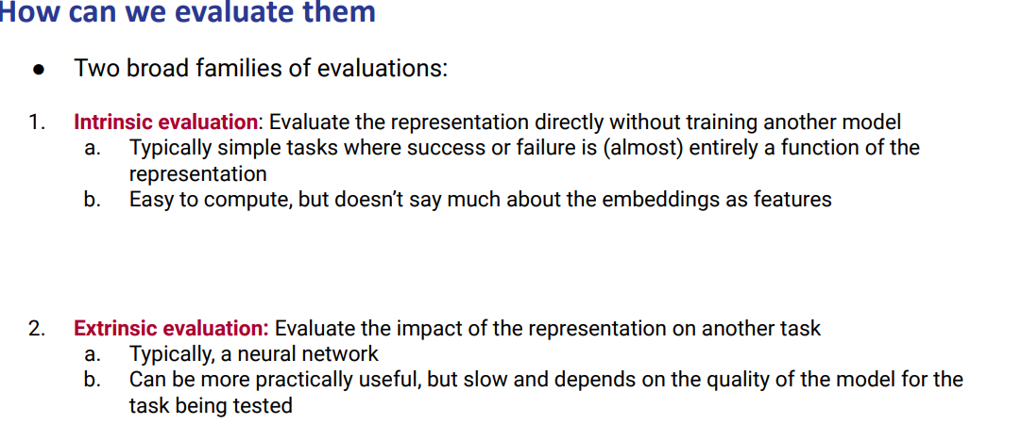
Once we have the embeddings we want to evaluate them.

We have intrinsic evaluation: we evaluate the representation directly without any further trade. You take the representation as it is and you can visualize or check if the similarity across vectors corresponds to something that makes sense. Like for man:woman = x : queen

Extrinsic evaluation: evaluate the impact of the representation on another task. Is more demanding than intrinsic evaluation you need to train another model that uses as initialization for a classifier doing another task. If you generate word embedding for example with word2vect, GloVe and FastText and then you use all of them one after the other to build three different classifiers and then you can check which one got the best performance. Check which method actually perform better or is generating better embedding

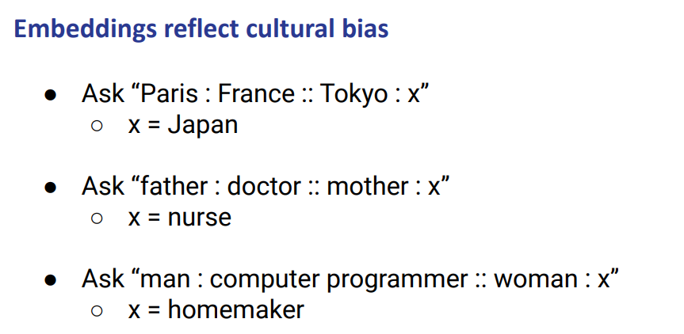
There are cultural biases that will be inside the model (because they are in the data). This is a problem, we must mitigate them

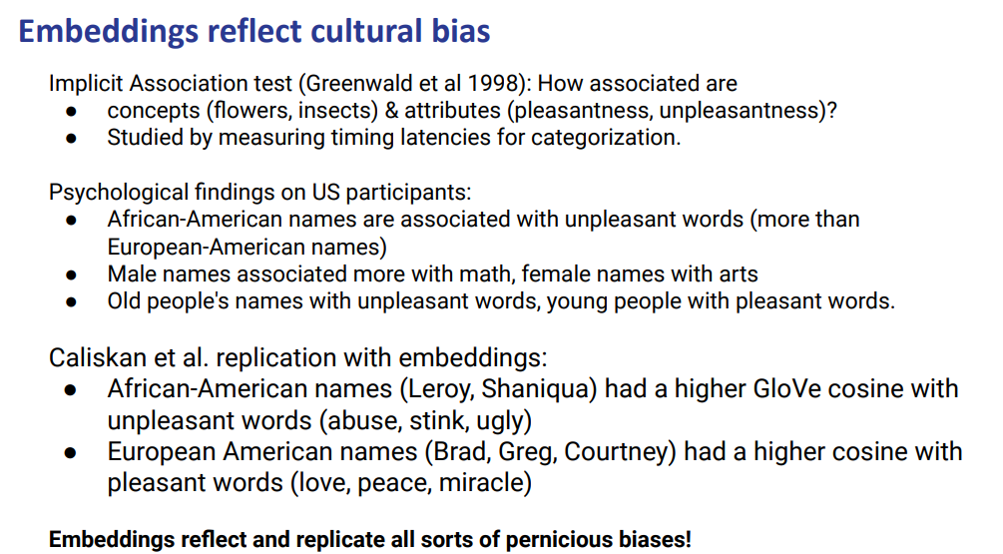
We have different types of bias. Biases implicit. We have biases with names

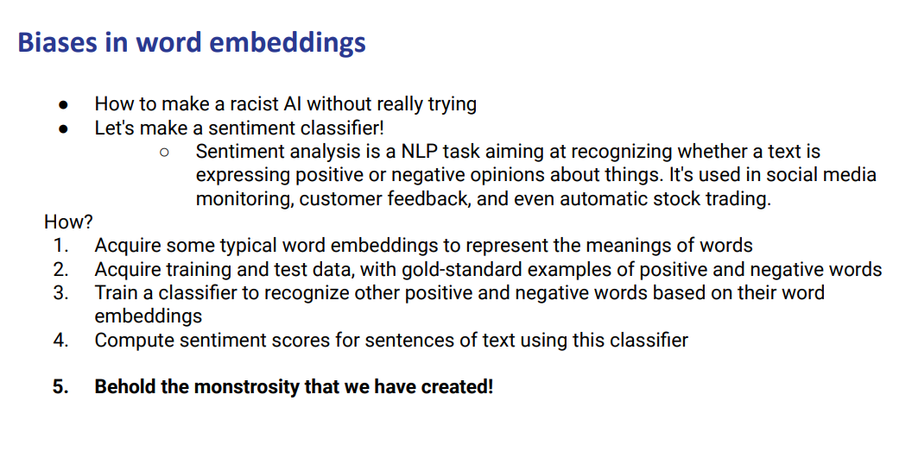

We want to create a sentiment classifier: try to recognise from text if it is expressing positive or negative opinions about things

use in review, social media, on customer feedback

We take training test data for our sentiment task.

we want to train a classifier to recognise if a word is positive or negative

we take some typical word embedding (word2Vec, GloVe, FasText) that are trained on massive corpus (are actually quite good) then we take training and test data for our task and the training data is just a list of words that a human marked as positive or negative.

In the test we have other words marked that were not present in the training data

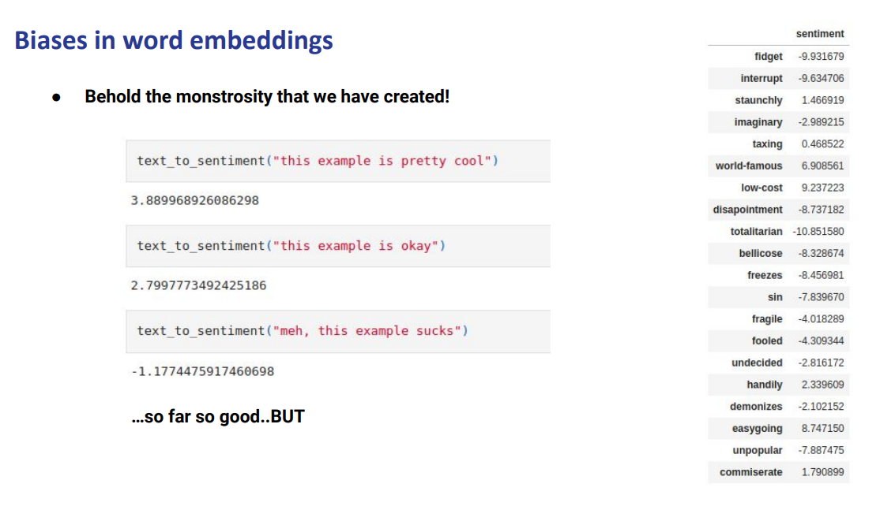
The model has learned something according to the sentiment. We can also import neural words

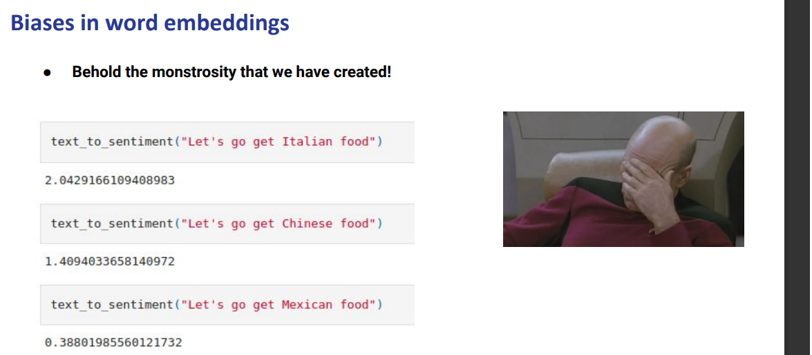

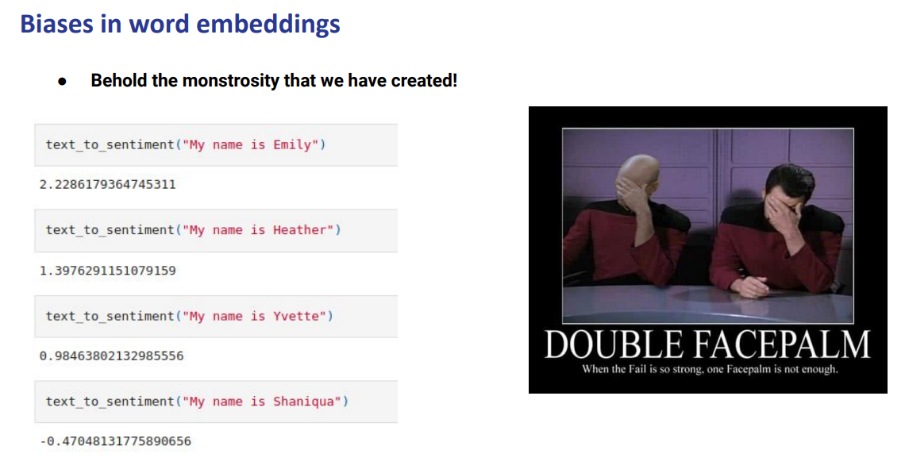
Mexican was considered negative

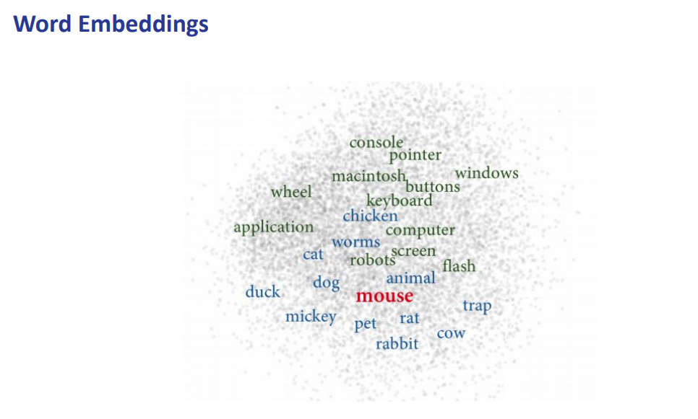
we visualize word embedding

what is the problem: we have a single word embedding for each word but each word can have multiple meanings

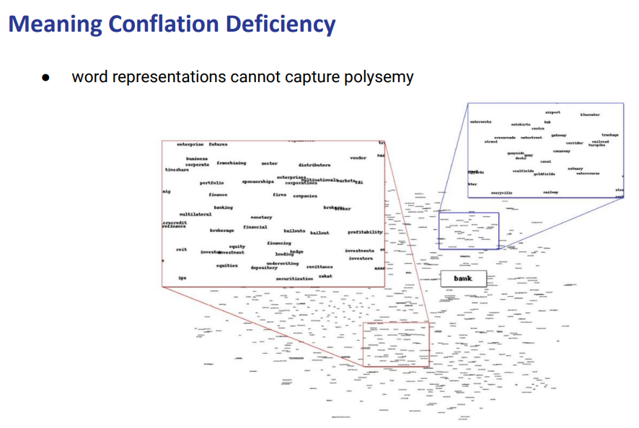
word representations in this way can not capture polysemy is meaning conflation deficiency
bank as the finance place or the river bank. We can see that it is slightly in the middle. Is not useful. Maybe in between there is another group of words that is not related in any way with bank

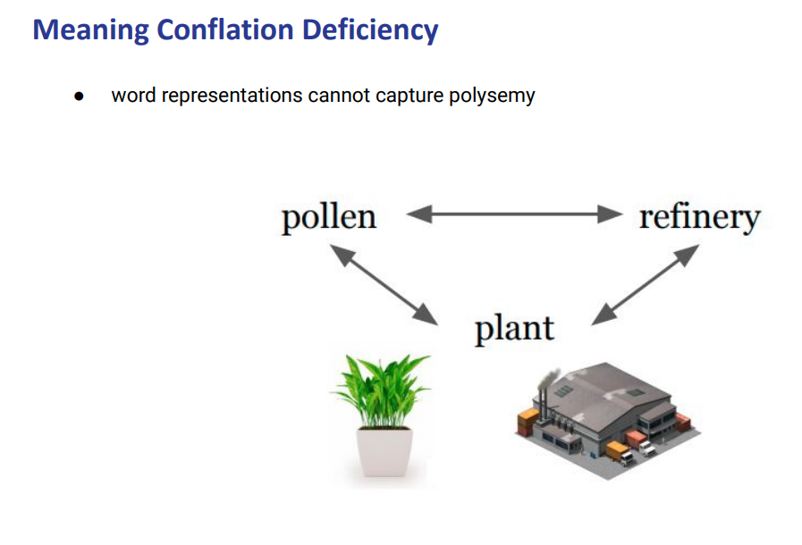

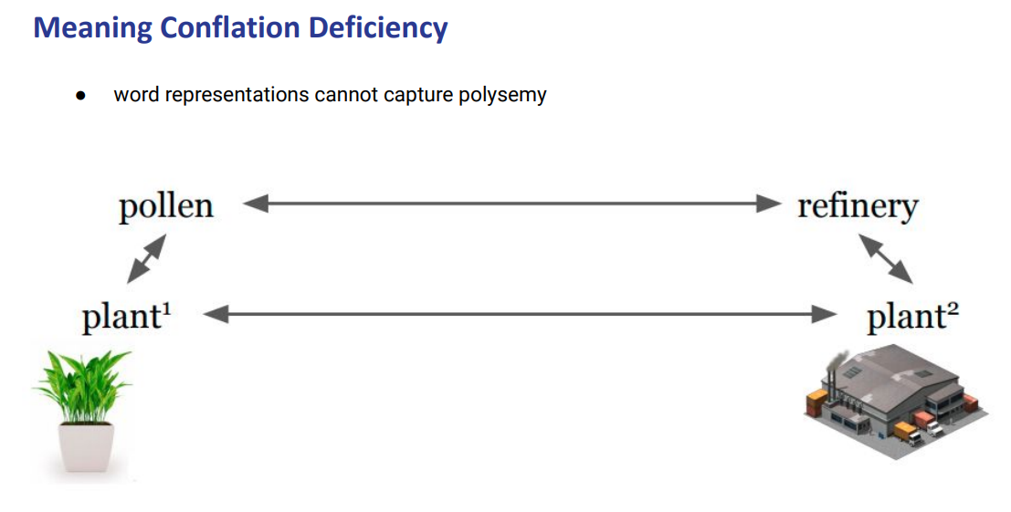
we want something like this, close to pollen but distance from refinery

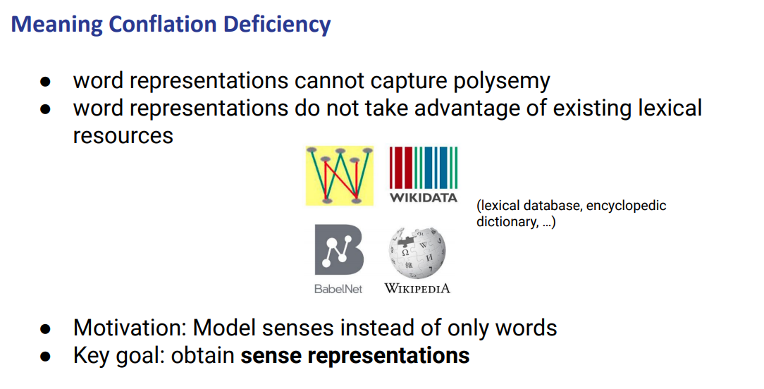
we do have lexical resources for the meaning and we exploit them to create sense embedding. We can use to encode words and sense embedding

we have some lexical resources, we haver a dictionary like that for each word it says the senses. provide information and relation to words. We can exploit to actual model sense

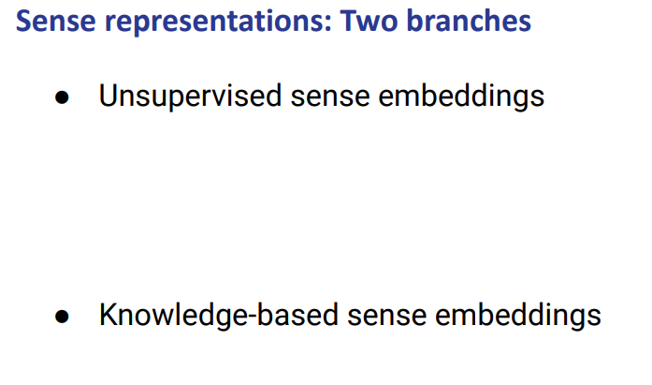
There are two branches. Unsupervised sense embeddings and knowledge based sense embeddings

both with pro and cons

two branches.

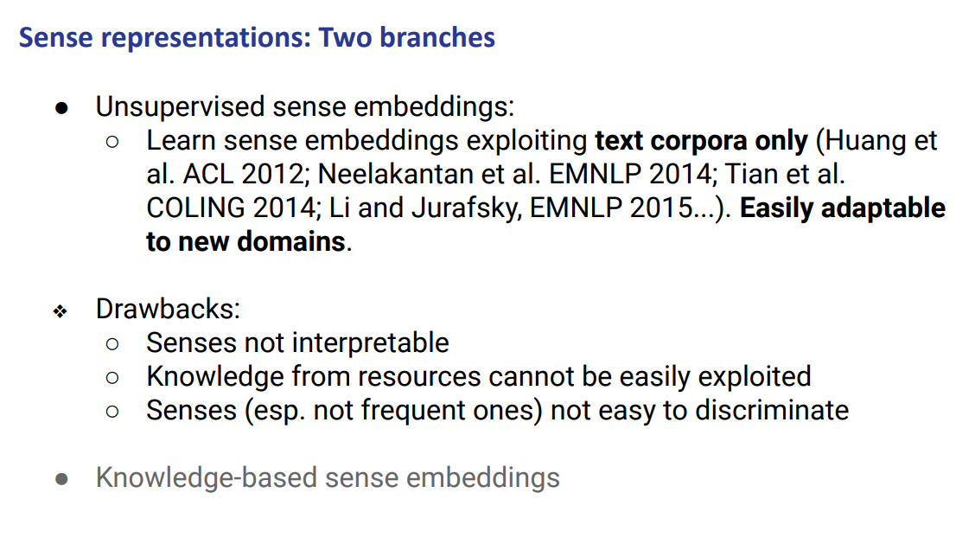
Unsupervised: you can apply to any text corpora, and are easily adaptable to new domains :)
but the senses are not interpretable (not easy to discriminate) :(

You try to create as many context as useful and in this context how many senses should be there

learn sense embedding, try to learn sense from raw corpus (wikipedia…) and how to learn you try to differentiate for each word different senses. they are not really link to any dictionary

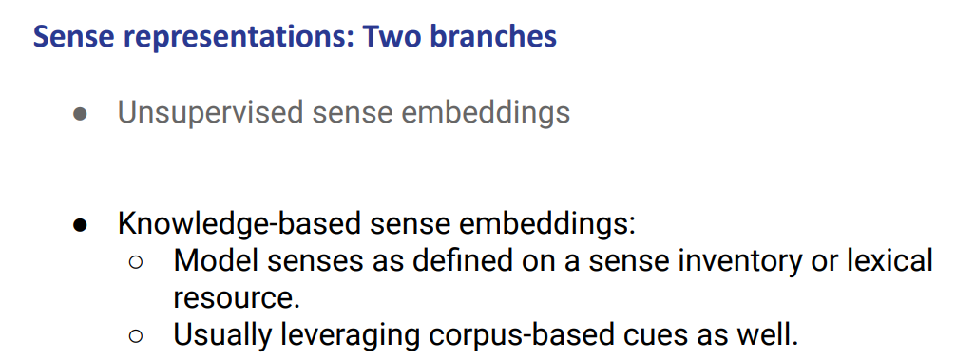
we basically know which is the meaning of each sense, we try to incorporate dictionary information within a moment

we haver leixcela information and we exploit it, use it for learning sense information, can actually see the +compkl
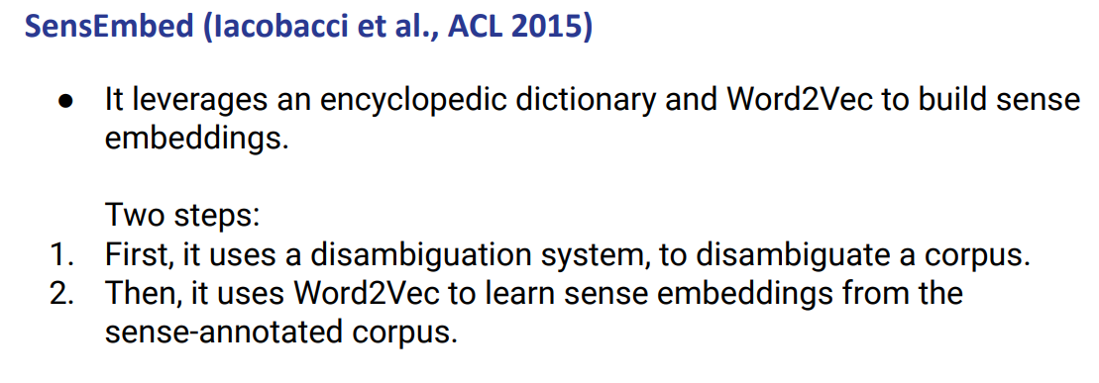
SensEmbed
you have a corpus and a disambiguation system

using the disambiguation system you try to generate for each word a sense to a dictionary, once it is done, you can use than the disambiguation corpus to learn sense embedding

sensembed is straightforward. Exploit a word sense disambigation system that disambiguate a corpus use to disambiguate a corpus and link each word to a sense. Use a method seens so far to actually learn word embedding

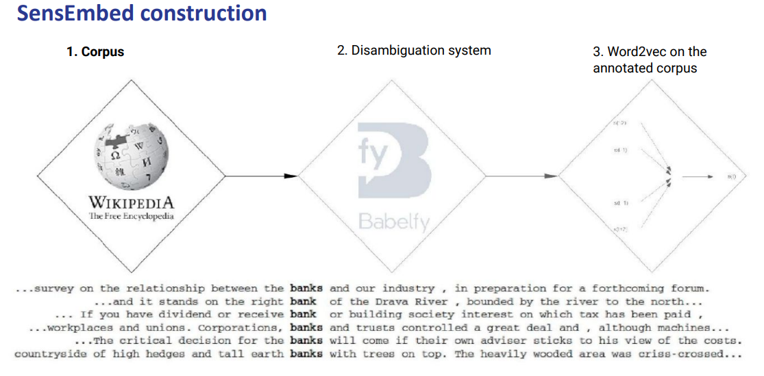
The target word is bank
bank two meanings

with wikipedia it is a bunch of sentences focused on banks

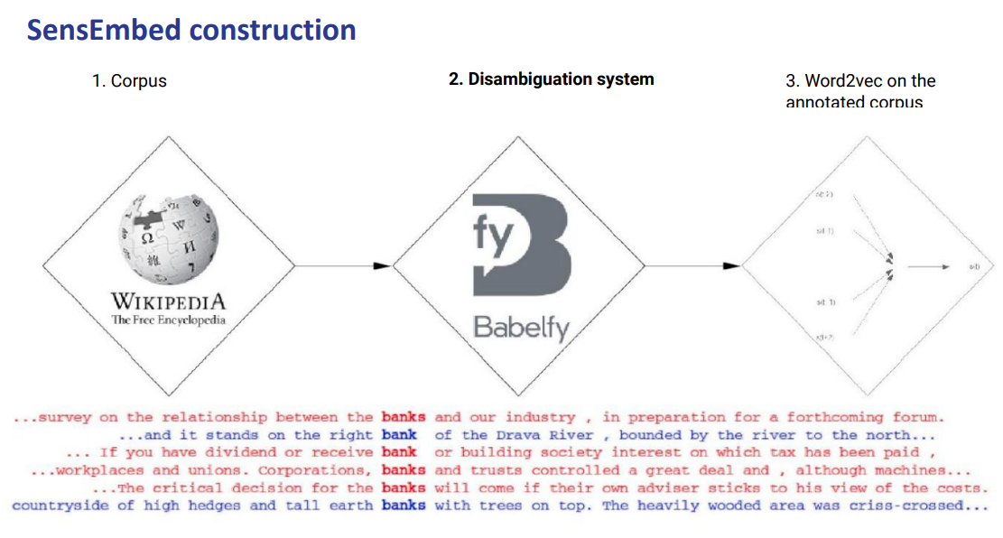
red one refers to the same meaning (financial term)
blue one other meaning (river term)

use babelfy (or other system) it takes a word and link it to a dictionary. Express the meaning, you relay on the accuray of the system (babelfy) but if the system is good enough the error will not impact the information. TYhe better system you use the better it is. Once you use for disambiguate you learn wordtovect

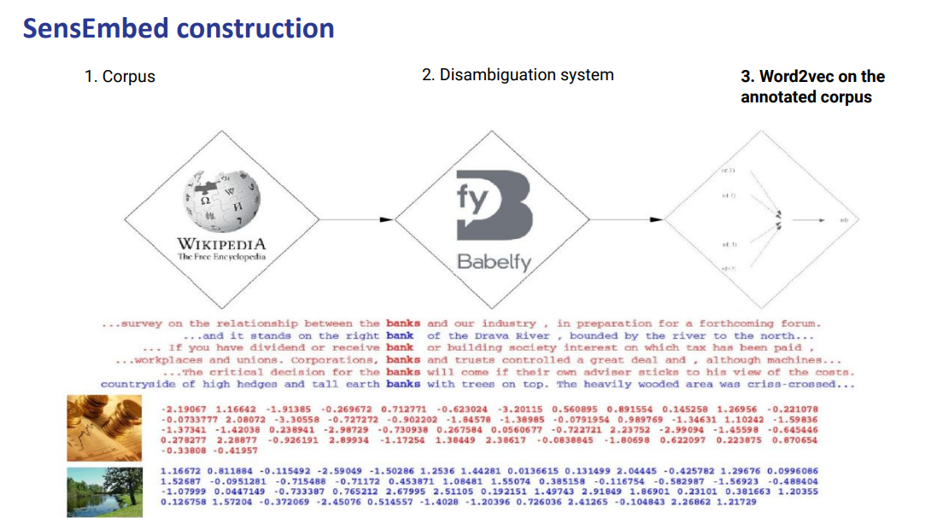
We can train our word2Vect system

It will create two embeddings.

The method SensEmbed is taking another system that is good enough and disambiguate the corpus and then we train a model. It performs well and create good embedding

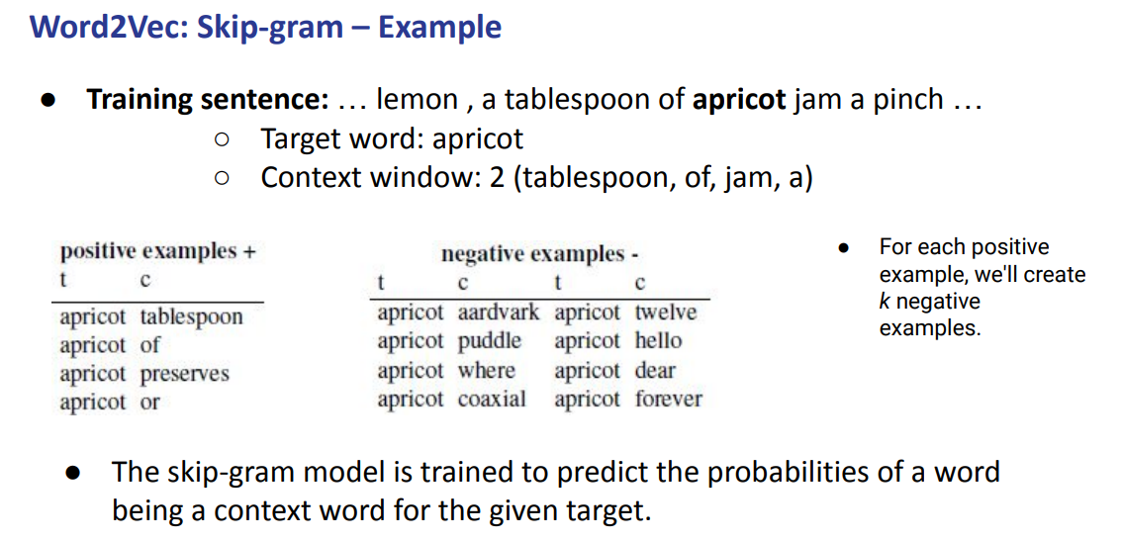

Mtrices where very sparse, 20 000 words. Most elements are equal to 0

all the other words will be 0, seems a waste of memory

try to have some techimque to learn a lower dimensions lvectopr. Start from something sparse to shrkin to something lower

from 20 000 to around 300. Are dense, most elements are not 0

Vector space that can be plotted adn we can compute cosine similarity across the vector

slide 6
exploding some algebra properties.
We started build the matrices in statistics, on hoe the words appear together

once we have the big matrix we want to map to a lower dense vector. We do the dimensionality reduction.

We can exploit this fact to do dimensionality reduction, we want to factorize the big matrix to a lower one. Each row represents a word.

slide7
most common tequneuce, we start with this sort of matrix and then our goal we moe from contrxtsd to features that are much smaller

slide 8
given a matrix, any rectangular matrix that matrix can be express as a product of 3 matrix

w: rows

m: columns, represent the new latent space (new feature that we wasnto to archive<)

singular valued matrix: is a diagonal, express the importance of these dimension. (0,0) there is most important feature,

V^{T} is a transpose of the original matrix

slide 10. how to reduce it.

We want something like k
+compl

we can plot the first two values+compl

slide 18
its a general method that words with the sparse matrix that uses the algebraic property.

slide 19
word emebeddings, low dimensionality vector from +compl

all words are embedded same space, can apply the cosine similarly between the teo because they live same space

ssme property as before, similar words have similar vectors, and sign distance should be close. Keep track of all the properties +compl

slide20
Word embeddings

+compl

slide21
similar words appear in simialr context, two words that share similar context are cloese in vector space

we need to build something that follows our intuition

instead of counting we want to predict, we want to predict words.
We want to build a classifier on a binary prediction task.

+compl
we don0t actually care about this task, take the classifier weights as the word embeddings.

We fram the task in a way that we do not need to conut but to rpedict. Take the weights of the classier asn word embeddings

slide24
in our case there is no need to annotate any data, the sentence itself is supervised training data. There is no need to have some sort of n level superposition, from the text we can see wether a word appear closer to another

slide25
we build up pair of words

slide26

how to get negative sample. from building negative words +compl

CBOW and SKIP GRAM
cbow: we wanbt to predict the target word given the context word, predict monkey given as input every likes banaas
SKIP GRAM: from the other way arounf predict every liked banas with iput monkey

Inverting input and ouput

CBOW given thecontext (we do not have w_{t} becuse it is monkey, we have the context +- 2)

Slide 29
takes an input the one single word and predict the context.

slide33
at the end both the input and output are one vector

slide34
at beginning you needs some sort of initial weights, just put random values that will be adapted later. We can use as a matrix +compl

and we want to minizmize+compl

word36
there 6 step choose embedding dimesnionality at the beginning and start random initilaizayion of narrow network you then construct the negetigve+compl

after that you trrow away the classifier+compl

once you have embeddings you can do other task+compl

slide39

slide43 we aere missing global statistic.

focus on exploding the global+xompl

the goal is to take advantage of global stat

+compl

slide44
we want to capture the global statistic.

slide45
we need to build some big matrix, we wanto to have a stastici on how the words co occur together. We want to makeècompl

slide46
consider two words they might exhibit a patticuarl aspect, coccurnce proababilities, if we take two words we are interest in the contec tof thermodynamics we see how the two words+compl

slide47 gives us some relationship, this relationship is given by some other probe words (aka the context)

GloVe we have for a given word k we have the word solid that is related toècompl

tbhe ratio of the probabilitiy should be large

water related to ice and stem should be close to1, as well as fashion (nothing related)

we can incorporate global statistics

compute the probability +compl

+com

slide51

slide56 if we add some sort of+compl

out of vocabulairiy qords, there are noise words and misspelling error. Just for a single letter you miss the entire word

can onlyform new words

slide63
properties of embeddings

some properties
each of them try to regulate a particular aspect

try to improve somehow other notion

there are lots of parameters to think about, the choice of the size of the context window will have an impact on the quality of the embedding

+compl

small context windows gets something more syntax, longer get something more semantic

slide65
build some analogy pattern, we can actually play with the distance

you can actually do the expòan around, you can see we have for example

slide66
more data helps, something is better better data is bigger thean +compl

wikipedia usually well written

slide69 :)
slide70
some tipes of flower of incense, flowers will bedimilar

names have biasases,

slide72

we take some typical word abnedding and so we have word emedbbing, take training test data and the training data are a list of words +compl

slide82

something get something that is not useful.

two branches.

slide87
we can apply to any text corpora, are easy adaètable +compl

the senses are not easy to discriminate

we try to create for each word different context useful
we basically know that each word+comp

slide89
corpususing the disambiguation to disambiguate aocrpis and linkage sense, once is +co

